Preface

This User Guide explains how to use the system to process export standby letters of credit. It assumes that you are familiar with the basic principles of trade finance relating to standby letters of credit, and with web browsers.

# Introduction

This chapter provides an overview of how the system handles standby letters of credit.

## Standby Letters of Credit in Trade Innovation

Trade Innovation includes two products to handle standby letters of credit:

* Import standby letters of credit
* Export standby letters of credit

Import standby letters of credit reflect the transaction from the perspective of the importer's bank, which is the issuing bank. The importer is referred to as the applicant.

Export standby letters of credit reflect the transaction from the perspective of other banks involved in the transaction in the exporter's country. These include the advising bank, which is the bank that notifies the exporter of the standby letter of credit, and the presenting bank, which is the bank at which the exporter presents the documents upon which payment depends. The exporter is referred to as the beneficiary.

Standby letters of credit are used where parties are concerned with the obligations between them, rather than specific goods or services.

Standby letters of credit provide security to beneficiaries in the form of a promise by the issuing bank on behalf of the applicant to reimburse the beneficiary for the amount of the standby letter of credit if the applicant defaults. They are governed by Uniform Code of Practice rules for documentary credits. The standby letter of credit is payable on sight, on receipt of a declaration from the beneficiary that the applicant has defaulted.

## Renewals, Increase and Reductions

Standby letters of credit can be renewed, reduced or increased automatically, or manually after review, according to schedules defined when the transaction was first entered on your system.

For renewals, these schedules allow you to define when and how often the transaction is to be renewed, and for how much - the original amount of the transaction or its value at the time of renewal. You can also define whether the customer is to be advised of the renewal, and if so, how soon before the renewal occurs.

For reductions and increases, these schedules define when the transaction is to be increased or reduced, and the amount of the increase or reduction, expressed as a fixed amount or as a percentage of the transaction's value. Again, you can define whether the customer is to be advised of the change of amount, and, if so, how soon before the reduction or increase takes place.

## Payment Terms

Trade Innovation includes facilities for the handling of:

* Sight credits
* Negotiation
* On demand credits
* Acceptance credits, where payment is made upon a term draft whose maturity date is determined by acceptance of the draft by a bank
* Deferred credits, where the beneficiary does not need to draw a bill of exchange to receive payment - the issuing bank guarantees that payment will be made at a specified future date if terms and conditions are fulfilled
* Mixed credits, which are a combination of sight and acceptance or deferred credits. The system supports part-payment to facilitate mixed credits
* Participations

## Financing and Discounting

If you have the financing module implemented you can enter advances against export standby letters of credit from within payment events. Loans can have interest charged in advance or in arrears, or they can be discounted.

The financing module also allows you to create financing transactions independent of any existing trade finance transaction. The trade finance transaction can then be associated with the financing transaction as it is created.

For a full description of the financing module's functionality see the Financing User Guide – Trade Innovation.

## Assignment of Proceeds

The system allows the assignment of proceeds to additional parties (see page 60) for export standby letters of credit. Each transaction can have any number of assignments associated with it, and these can be viewed as part of the master details.

## Licenses

The system includes facilities for the use of licenses with transactions of the type described in this Guide. Your bank can also make returns to the central licensing authority on a regular basis to show the utilisation of the licenses issued to customers.

One or more licenses can be linked to a transaction and a reservation made for the amount of the transaction. When a claim is received, a drawdown can be made against the license. Full validation between the transaction and license is provided to ensure that licenses do not become overdrawn.

If the amount of the transaction is increased or decreased during an amendment event, then additional reservations can be made for an increase or the balance reinstated for a decrease. Any unutilised balance on expiry or cancellation can be (optionally) reinstated on the license.

See the Licenses User Guide – Trade Innovation for details of licenses.

## Participating a Transaction

If you have the participations module implemented, you can participate a transaction using an existing participation deal, or create a new participation deal for use with that transaction.

You can participate a transaction from within the Advise event, or later from within a Maintain Liability event. At either of these stages, you can either select an existing agreed participation deal, or create a new deal.

If the amount of a transaction is changed by an Amend event, or by the transaction being paid, expired, or cancelled, a Drawdown/Revolve Commit Amt event may be created as a subsidiary event to update the commitment amount available on the participation deal. This will occur under the following circumstances:

* If the amount is increased, a drawdown will take place to reduce the amount available on the participation deal
* If the amount is decreased, including being reduced to zero when the transaction is paid, expired, or cancelled, a revolve will be used to increase the amount available on the participation deal only if the participation deal is defined as revolving

A Drawdown/Revolve Commit Amt event may be created by the following events:

* Amend
* Cancel
* Expire
* Maintain Liability
* Documents Presented
* Outstanding Presentation
* Renew
* Reduction/Increase

If the participation deal itself is amended in such a way as to alter a participant's share, a Maintain Liability subsidiary event is automatically generated for each transaction affected by the amendment. This updates the transaction and the charges associated with it to take account of changes to the participation deal.

For a full description of using participation deals, see the Participated Deals User Guide – Trade Innovation.

## Credit Risk Management

If your bank has implemented a credit risk management application, your system will perform on-line credit limit checking as necessary as part of the life-cycle of a transaction. Depending on how your system has been configured, account manager approval for a credit line utilisation may be required always, or only when overline conditions are detected.

See the Common Facilities User Guide – Trade Innovation for more information on credit risk management.

## Processing Export Standby Letters of Credit

The table below list the events covered in this Guide, explaining what each event allows you to do. The table lists the names given to events when the system is delivered. Your bank can change these names once the system is installed. Consequently, the names in your version of the system may be different from the ones listed here.

There are two names for each event:

* The full name, which is displayed when you choose a new event
* The short name, which is displayed in the Work in Progress pane of the Master Summary window

This Guide uses the full name of each event, as delivered with the system.

In addition to the events listed in the table, you can also use the functionality described in the Common Facilities User Guide – Trade Innovation when processing transactions.

|  |  |  |
| --- | --- | --- |
| Full Name | Short Name | What it Does |
| Adjust | Adjust | Allows you to make changes to any of the information held for a standby letter of credit (see page 55). |
| Advise | Advise | Allows you to create a standby letter of credit and produce a full advice for the beneficiary (see page 5). |
| Advise Reduction/Increase | Adv Rec/Inc | Allows a reduction or increase in the amount of a standby letter of credit to be advised to parties automatically, prior to the reduction or increase (see page 45). |
| Advise Renewal | Adv Renewal | Allows renewal of a standby letter of credit to be advised to parties automatically (see page 48). |
| Amend | Amend | Allows you to make amendments to the basic details of a standby letter of credit (see page 52). |
| Beneficiary Response to Amend | Amd Rspnse | Allows you to enter details of the beneficiary's response to an amendment (see page 54). |
| Beneficiary Response to Cancel | Can Rspnse | Allows you to enter details of the beneficiary's response to a cancellation (see page 58). |
| Cancel | Cancel | Allows you to cancel a standby letter of credit (see page 58). |
| Documents Presented | Docs Pres | Allows you to record details of documents presented and to make claims against the issuing bank when the beneficiary or another bank presents documents for payment (see page 25). |
| Finance | Finance | Available only if your system has the financing module implemented. Allows you to create an independent financing transaction.  See the Financing User Guide – Trade Innovation. |
| Maintain Liability | Maint Liab | Updates a participated standby letter of credit to take account of changes in the participation deal. See the Participated Deals User Guide – Trade Innovation. |
| Outstanding Presentation | Outst Presn | Allows you to continue processing a previous presentation (see page 34). |
| Receive Acknowledgement | Rec Acknow | Allows you to record the advising bank's acknowledgement of receipt of a standby letter of credit (see page 23). |
| Reduction/Increase | Red/Inc | Allows a standby letter of credit to be reduced or increased automatically (see page 46). |
| Renew | Renew | Allows a standby letter of credit to be renewed automatically (see page 44). |

# Advising an Export Standby Letter of Credit

This chapter explains how to use the system to initiate an export standby letter of credit on your system using an Advise event.

## Advising an Export Standby Letter of Credit

The Advise event enables you to enter full details of an export standby letter of credit. To initiate an Advise event, in the Masters window, select the Team and Behalf of branch and use the drop-down list in the New Masters pane to select 'Export Standby LC', then press New. The system creates an Advise event at either a Log step (see page 5) or Input step (see page 7), depending on how the Workflow orchestration controlling the event is configured. See the *Workflow Tailoring User Guide* – Trade Innovation for details.

### Logging an Advice

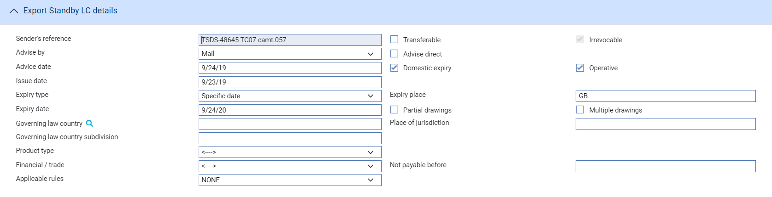 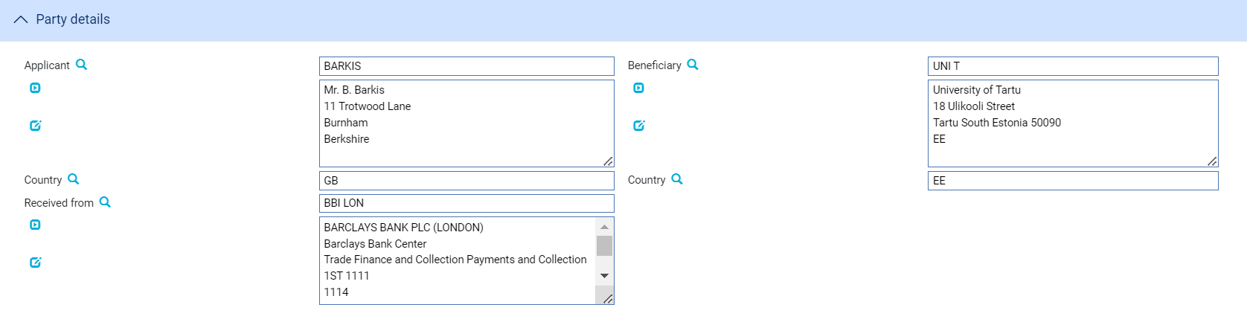 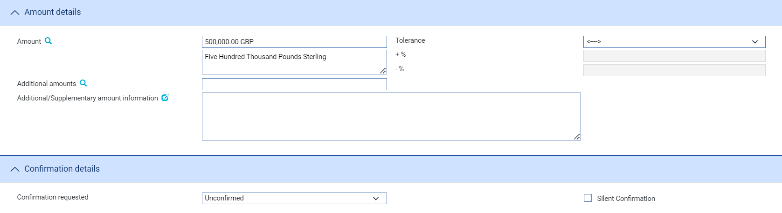 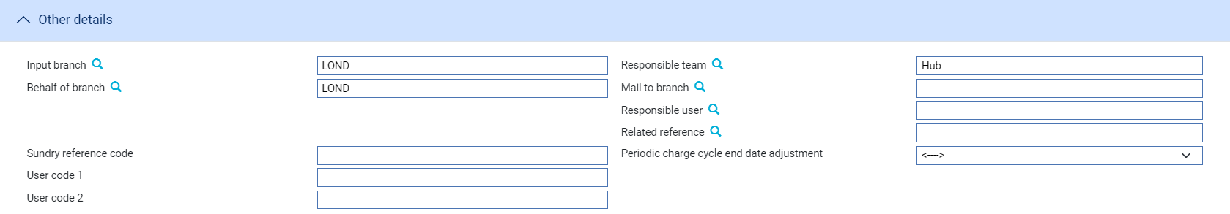

The following table lists the fields shown in a Log window and explains what to enter into them:

| Field | What to Enter | | |
| --- | --- | --- | --- |
| Sender's Reference | The sending bank's reference. This is stored on the master record as the principal party's reference. | | |
| Issue Date | The date the letter of credit was issued. | | |
| Product Type | If your bank has set up product types, select the appropriate product type from the drop-down list on this field. | | |
| Expiry Date | The expiry date. | | |
| Expiry Place | The location at which the expiry date applies. | | |
| Applicant | The party making the application. | | |
| Beneficiary | The beneficiary. | | |
| Received From | The party from whom you received it. | | |
| Amount | The amount. | | |
| Tolerance | Specify how the amount is being expressed. Select from one of the following: | | |
|  | Exact | If the amount is the exact value of the letter of credit. | |
|  | About | If the amount given in the Amount field is within 10% either way of the expected value of the letter of credit. | |
|  | Other | If you select this option, use the -% and +% fields to specify as a percentage how much more or less than the final value of the letter of credit the amount entered is allowed to be. | |
|  | Not Exceeding | If the final value of the letter of credit is expected to be no more than the amount entered, and not less than 95% of the amount entered. | |
|  | Min/Max | If you select this option the system displays a + Amount and a - Amount field. Use them to specify as an amount how much more or less than the final value of the transaction the amount entered is allowed to be. | |
| Available By | Select the tenor of the payment. | | |
| Confirmation Requested | Select from one of the following: | | |
|  | Confirmed | | If you are confirming it. |
|  | Unconfirmed | | If you do not intend to confirm it. |
|  | May Add | | If you may confirm it at a later point. |
|  | If you select 'Confirmed' or 'May Add' additional fields are displayed. Use them to enter the amount of the credit that is confirmed. You may enter an amount or a percentage; this is usually 100%. | | |
| Silent Confirmation | If you have received no confirmation instructions (and the Confirmation Requested field is set as 'Unconfirmed') the Silent Confirmation field allows you as advising bank to confirm the transaction at the request of the beneficiary. Again, additional fields are present that allow you to enter the amount of the credit that is confirmed. | | |
|  | If a transaction receives silent confirmation in this way, it is otherwise still treated as unconfirmed. | | |
| Input Branch | The input branch for the transaction. The input branch is set from either:   * the accounting branch from the user’s team, or * the transaction branch for the user if the user has a default transaction branch or is locked to a specific branch, or * a branch associated with the user where the user can enter transactions for several branches for a team | | |
| Behalf Of Branch | The behalf of branch for the transaction as entered by the user or set from the incoming SWIFT or gateway message. The behalf of branch determines the parameter sets that are to be used to generate charges, documents, postings, etc. during transaction processing. The branch can be changed to any other branch within the same main banking entity that shares the same parameter sets. | | |
| Responsible Team | The team that has overall responsibility for the master e.g. as the contact to resolve any queries or issues regarding the master and associated events. The system defaults the responsible team when creating the transaction as follows:   * Manual – set from team creating the transaction * Gateway – set from the team specified on the incoming message (if present and valid) otherwise to the team to which the transaction is assigned through workflow allocation based on the behalf of branch * SWIFT – set to the team to which the transaction is assigned through workflow allocation based on the behalf of branch   It can be changed, if required, to either the team associated with the primary customer, default team for the product or the user’s current team. | | |
| Related Reference | If the transaction is associated with an existing transaction, enter the reference number of that transaction here. | | |

### Entering Full Details of the Advice

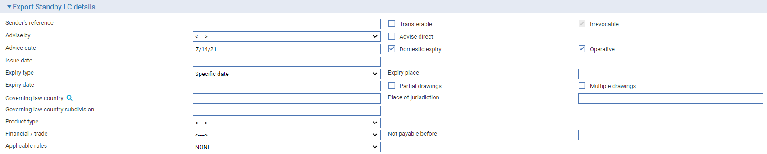

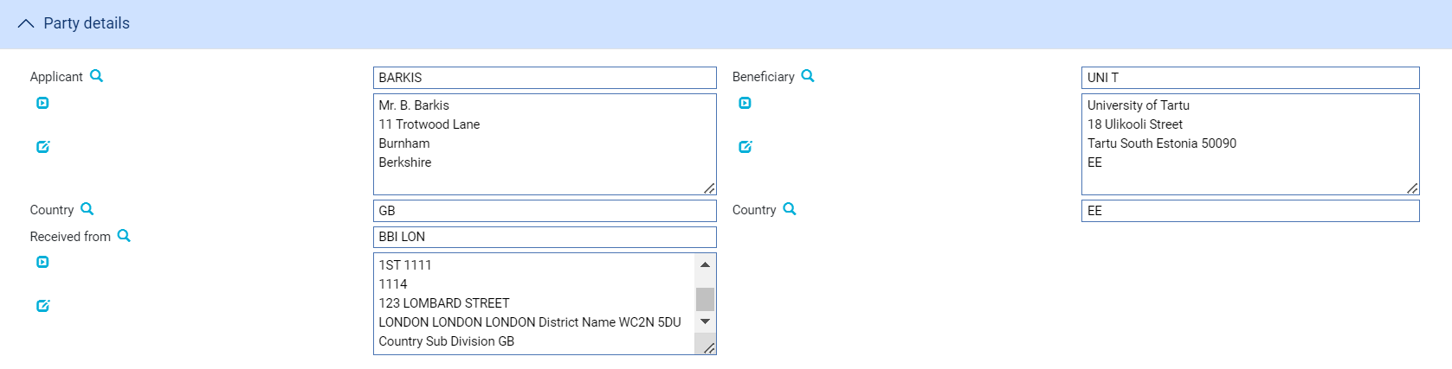 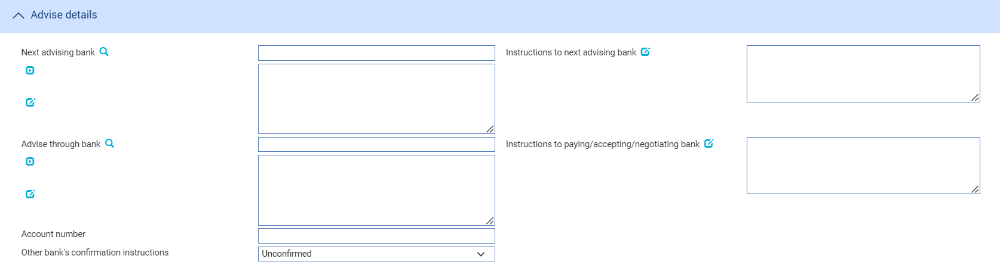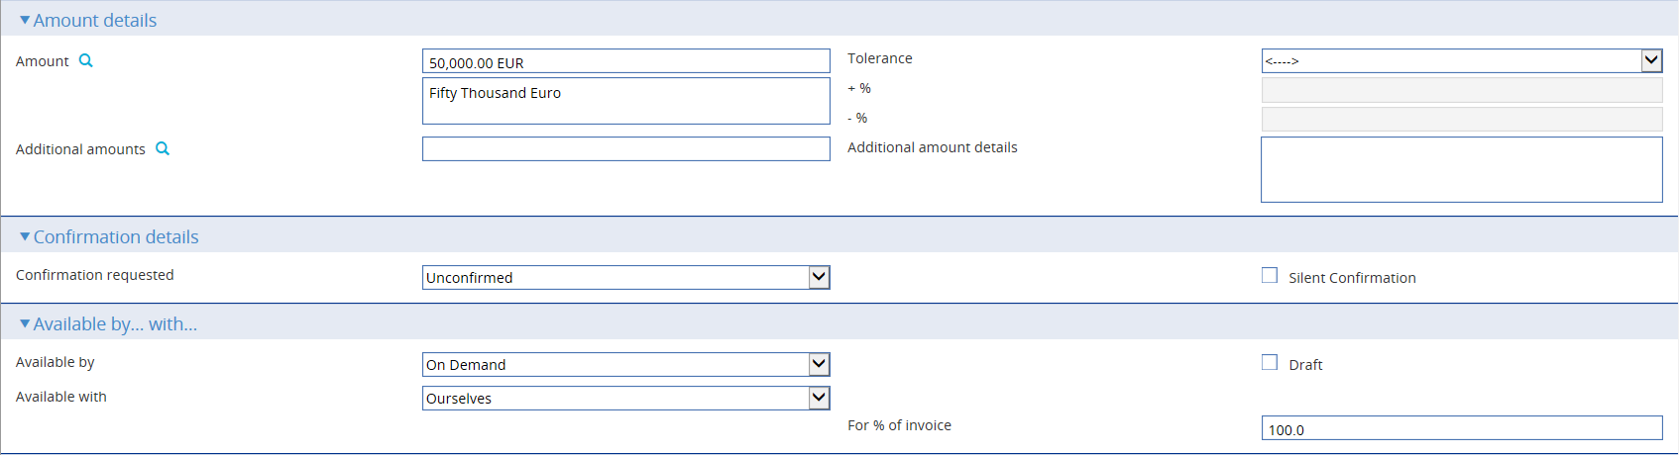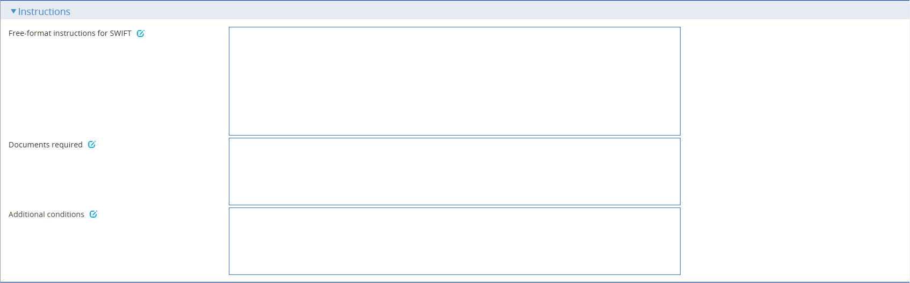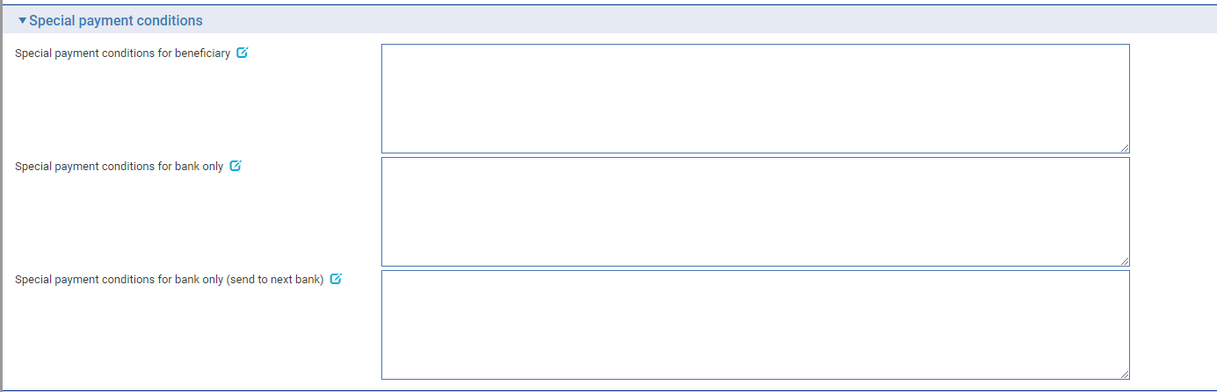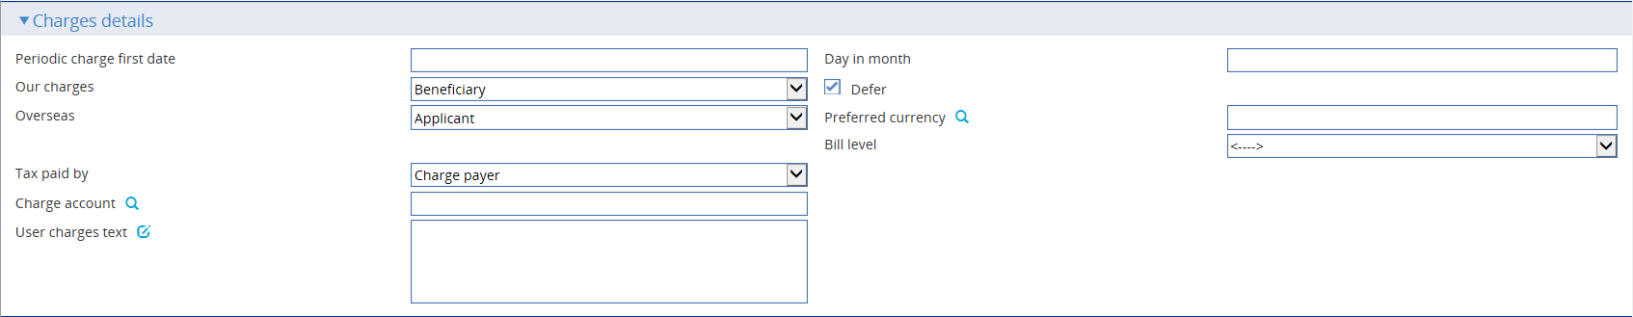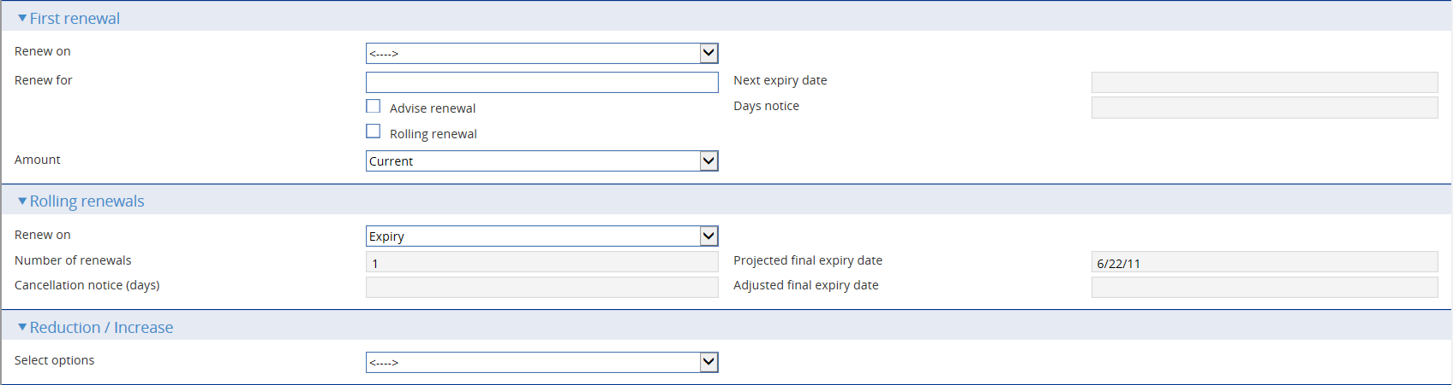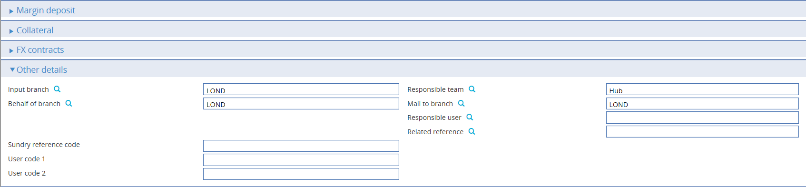 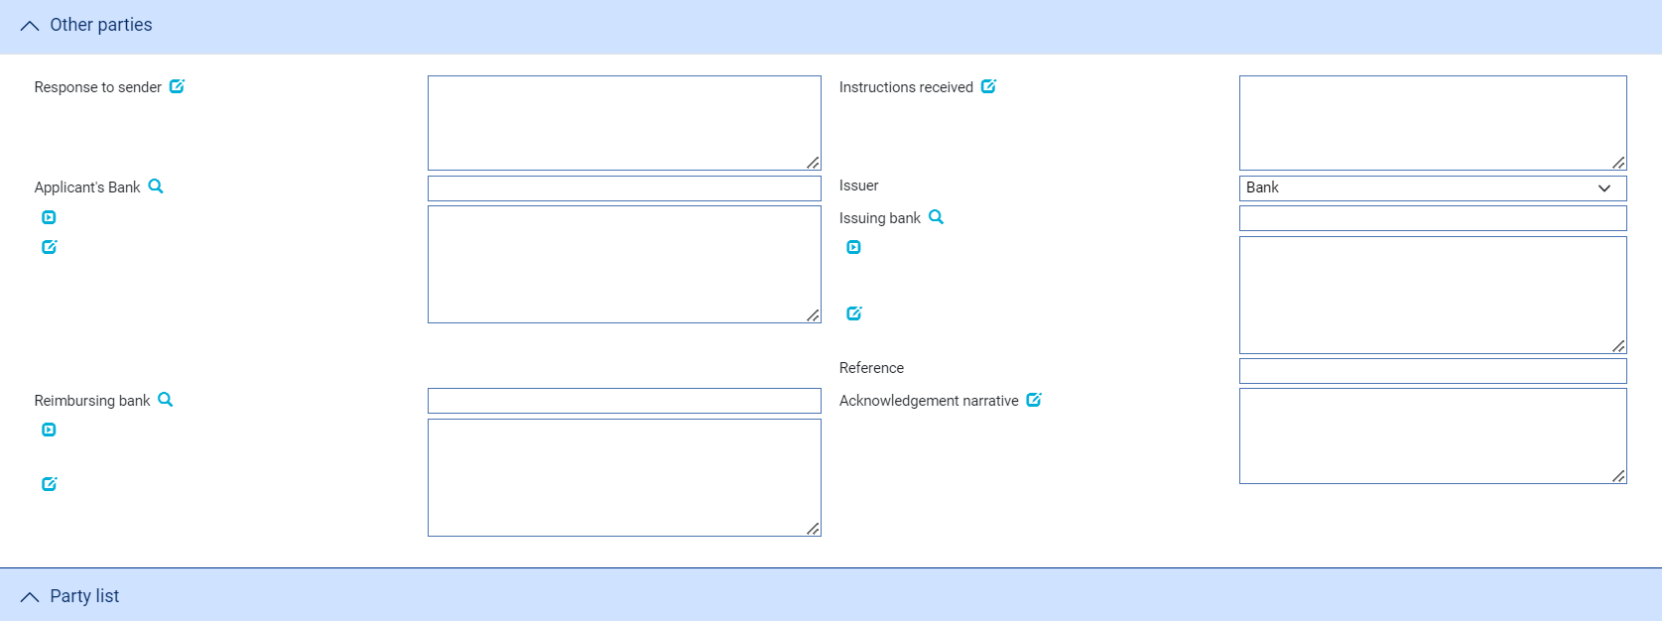

An Input step uses the following panes to enter full details of the advice:

* The Export Standby Details pane (see page 11)
* The Party Details pane (see page 13)
* The Advise Details pane (see page 13)
* The Amount Details pane (see page 14)
* The Confirmation Details (see page 15)
* The Available By\With (see page 15)
* The Instructions pane (see page 17)
* Special Payment Conditions (see page 17)
* The Charges Details pane (see page 18)
* The First Renewal pane (see page 20)
* The Rolling Renewal pane (see page 20)
* The Reduction/Increase pane (see page 21)
* The Margin Deposit pane
* The Collateral pane
* The FX Contracts pane
* The Other Details pane (see page 22)
* The Other Parties pane (see page 23)
* The Party List pane

The following panes are displayed if the standby letter of credit involves a trade transaction:

* The Shipment pane (see page 15)
* The Goods pane (see page 16)

Instructions on using the Margin Deposit pane, the Collateral pane, the FX Contracts pane and the Party List pane are given in the Common Facilities User Guide – Trade Innovation.

#### The Export Standby Details Pane



The following table explains what to enter into the fields displayed in the Export Standby Details pane:

|  | Field | What to Enter | |
| --- | --- | --- | --- |
|  | Sender's Reference | The sending bank's reference. This is stored on the standby letter of credit's master record as the principal party's reference. | |
|  | Advise By | The method of transmission to be used to send the standby letter of credit. If you leave this field blank the system will use the method specified in the address details for the recipient of the standby letter of credit. | |
|  | Advise Date | The date the standby letter of credit was created on your system. The system uses today's date as the default. | |
|  | Issue Date | The date the standby letter of credit was issued. | |
|  | Expiry Date | The expiry date of the standby letter of credit. | |
|  | Expiry Place | The location at which the expiry date applies. | |
|  | Governing law country | The governing law country that is applicable to the standby letter of credit. | |
|  | Governing law country subdivision | The governing law subdivision of the country applicable to the standby letter of credit. | |
|  | Governing law text | The governing law that is applicable to the standby letter of credit. | |
|  | Product Type | Select the type of standby letter of credit. If your bank has set up product types for export standby letters of credit, select the appropriate product type from the drop-down list on this field. Depending on how your system has been configured, this field may be mandatory. | |
|  | Financial/Trade | Select 'Financial' if the standby letter of credit is financial or 'Trade' if the standby letter of credit is associated with an underlying trade transaction. | |
|  | Transferable | Check this field if the standby letter of credit is transferable. | |
|  | Revocable | Check this field if the letter of credit is revocable.   1. **Revocable** flag is protected and set to Irrevocable when system option SWIFTVersion is set to 2018.   Set Zone system option ‘AllowRevocableLCs’ to make the flag editable and enable user to issue revocable letter of credit with even if SWIFT 2018 is enabled. | |
|  | Advise Direct | Check this field if the standby letter of credit is being advised directly to the beneficiary. | |
|  | Domestic Expiry | Check this box if the expiry is domestic. Leave it blank if the expiry is overseas. | |
|  | Operative | Indicate whether the standby letter of credit is operative or not. By default the standby letter of credit is operative and the box is checked. If you uncheck this box, then the standby letter of credit will remain inoperative until you use an Amend event to make it operative. | |
|  | Partial Drawing | Check this box if partial drawings on the standby letter of credit are allowed. | |
|  | Not Payable Before | The earliest agreed payment date. Payment is not allowed before this date. | |
|  | Use Free Format | Check this box if the standby letter of credit is to be issued using a SWIFT MT799 message. This field is visible only if you selected SWIFT or Telex via SWIFT in the Issue By field. If you leave this field unchecked, the standby letter of credit will be issued using a SWIFT MT760 message. | |
|  | Applicable Rules | Present only if your bank has implemented SWIFT 2006 changes. It allows you to select additional information to be included in the relevant SWIFT MT700 (MT710 and MT720) message generated by the event.  Select one of the following to indicate the rules applied to the issue of the documentary credit: | |
|  |  | UCP LATEST VERSION | The documentary credit is subject to the version of the ICC Uniform Customs and Practice for Documentary Credits, International Chamber of Commerce, Paris, that is in effect on the date of issue.  This is used as the default. |
|  |  | EUCP LATEST VERSION | The documentary credit is subject to the version of the Supplement of the ICC Uniform Customs and Practice for Documentary Credits for Electronic Presentations, International Chamber of Commerce, Paris, that is in effect on the date of issue. |
|  |  | UCPURR LATEST VERSION | The documentary credit is subject to the version of the ICC Uniform Customs and Practice for Documentary Credits and the version of the Uniform Rules for Bank-to-bank Reimbursements under documentary credits, International Chamber of Commerce, Paris, that is in effect on the date of issue. |
|  |  | EUCPURR LATEST VERSION | The documentary credit is subject to the version of the Supplement of the ICC Uniform Customs and Practice for Documentary Credits for Electronic Presentations and the version of the Uniform Rules for Bank-to-bank Reimbursements under documentary credits, International Chamber of Commerce, Paris, that is in effect on the date of issue. |
|  |  | ISP LATEST VERSION | For standby letters of credit only. The documentary credit is subject to the version of the ICC International Standby Practices, International Chamber of Commerce, Paris, that is in effect on the date of issue. |
|  |  | OTHR | The documentary credit is subject to other rules. Use the Other Applicable Rules field to specify those rules (up to 35 characters). |
|  | Other Applicable Rules | Displayed only if you select OTHR in the previous field. | |

#### The Party Details Pane

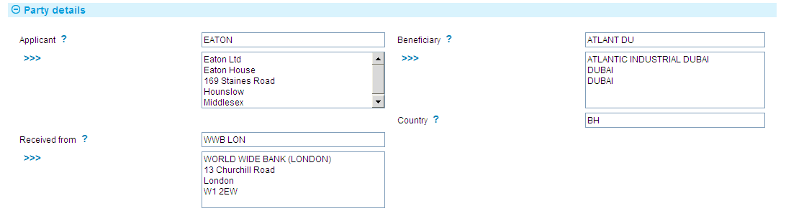

The following table explains what to enter into the fields displayed in the Party Details pane:

|  |  |  |
| --- | --- | --- |
|  | Field | What to Enter |
|  | Applicant | The principal party. |
|  | Beneficiary | The beneficiary. |
|  | Country | The beneficiary's country of residence. |
|  | Received From | The party from which you received the standby letter of credit.. |

#### The Advise Details Pane

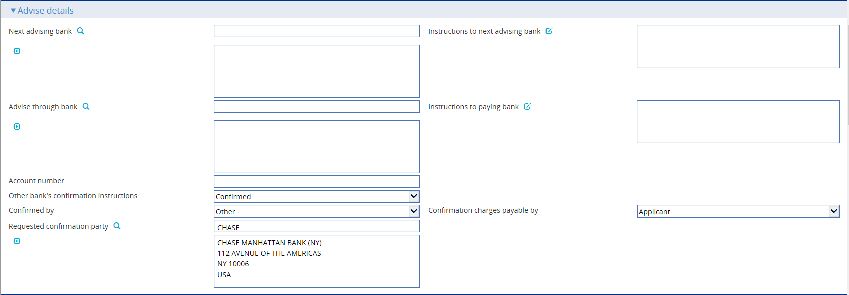

The following table explains what to enter into the fields in the Advise Details pane:

|  |  |  |  |
| --- | --- | --- | --- |
| Field | What to Enter | | |
| Next Advising Bank | The next advising bank. | | |
| Instructions to Next Advising Bank | Any instructions to the next advising bank, including confirmation instructions. | | |
| Advise Through Bank | The Advise Through bank. | | |
| Account Number | The number of your bank's account with the Advise Through bank. | | |
| Instructions to Paying Bank | Any instructions to the paying/accepting/negotiating bank. | | |
| Other bank’s confirmation instructions | Select one from the following options: | | |
|  | Confirmed | If you want the requested confirmation party to confirm the letter of credit. | |
|  | Unconfirmed | If you do not want the requested confirmation party to confirm the letter of credit. This is the default value. | |
|  | May Add | If you have no preference whether the requested confirmation party confirms the letter of credit or not. | |
| Confirmed By | Select one from the following options: | | |
|  | Blank | | The default value for this field. |
|  | Ourselves | | If you are requested to add confirmation or may add confirmation. |
|  | Advise Through Bank | | If the advise through bank is requested to add its confirmation or may add its confirmation. |
|  | Received from bank | | If the sender of the credit is requested to add its confirmation or may add its confirmation. |
|  | OTHER | | If other bank is requested to add its confirmation or may add its confirmation. |
|  | This field is displayed and mandatory when Other Bank’s Confirmation is set to CONFIRMED or MAYADD. | | |

#### The Amount Details Pane

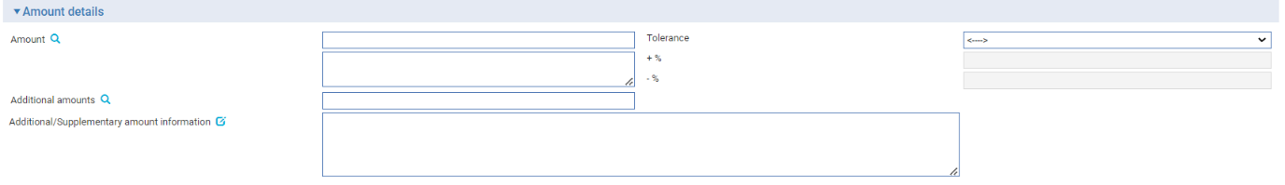

The following table explains what to enter into the fields in the Amount Details pane:

|  |  |  |
| --- | --- | --- |
| Field | What to Enter | |
| Amount | The amount and currency of the transaction. The system displays the amount and currency in the language of your system beneath these fields. You can edit this text, if necessary. | |
| Tolerance | Specify how the amount is being expressed. Select from one of the following: | |
|  | Exact | If the amount is the exact value of the letter of credit. |
|  | About | If the amount given in the Amount field is within 10% either way of the expected value of the letter of credit. |
|  | Other | If you select this option, use the -% and +% fields to specify as a percentage how much more or less than the final value of the letter of credit the amount entered is allowed to be. |
|  | Not Exceeding | If the final value of the letter of credit is expected to be no more than the amount entered, and not less than 95% of the amount entered. |
|  | Min/Max | If you select this option the system displays a + Amount and a - Amount field. Use them to specify as an amount how much more or less than the final value of the transaction the amount entered is allowed to be. |
| Additional Amounts | Any amounts payable to the beneficiary in addition to the principal amount of the transaction. These might include, for example, local freight charges.  If you enter an amount, it is added to the amount of liability under the transaction. If you use a different currency for the amount, then the amount is converted to the currency of the transaction using the current spot rate. | |
| Additional/ Supplementary Amount Details | A text description of what any additional amounts are for. | |

#### The Confirmation Details Pane



In the Confirmation Requested field select one of the following values:

|  |  |
| --- | --- |
| Confirmed | If you have been instructed by the issuing bank to add your confirmation. |
| Unconfirmed | If you have been instructed not to add your confirmation. |
| May Add | If you have been instructed that you may add your confirmation at the beneficiary's request. |

If you select 'Confirmed' or 'May Add' additional fields are displayed.



Use them to enter the amount of the credit that is confirmed. You may enter an amount or a percentage; this is usually 100%.

If you have received no confirmation instructions (and the Confirmation Requested field is set as 'Unconfirmed') the Silent Confirmation field allows you as advising bank to confirm the transaction at the request of the beneficiary. Again, additional fields are present that allow you to enter the amount of the credit that is confirmed.

If a transaction receives silent confirmation in this way, it is otherwise still treated as unconfirmed.

#### The Available By/With Pane

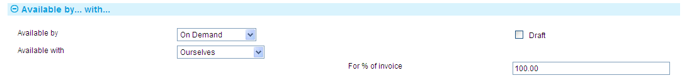

The First field is used to set the tenor of the payment. See the Common Facilities User Guide – Trade Innovation for instructions.

The following table explains what to enter into the fields in the remaining fields:

|  |  |  |
| --- | --- | --- |
| Field | What to Enter | |
| Available With | Select from one of the following to indicate which party the beneficiary should present documents for payment to:   * Ourselves * Issuing Bank * Advising Bank * Any Bank * Any Bank in (city) - the system displays a field, into which you can enter the name of the city * Any Bank in (country) - the system displays a browser which you can use to select the country * (named bank) - the system displays fields which you can use to specify the bank   When you have made your selection press Refresh. Additional fields may be displayed, depending on what you have selected: | |
|  | Country | If Available With is set to 'Any Bank in Country' identify the country. |
|  | City | If Available With is set to 'Any Bank in City' identify the city. |
|  | Named Bank | If Available With is set to 'Named Bank' identify the bank. |
| For % of Invoice | The percentage of the invoice value of the goods that the transaction covers. The system uses 100% as the default value. | |

#### The Shipment Pane

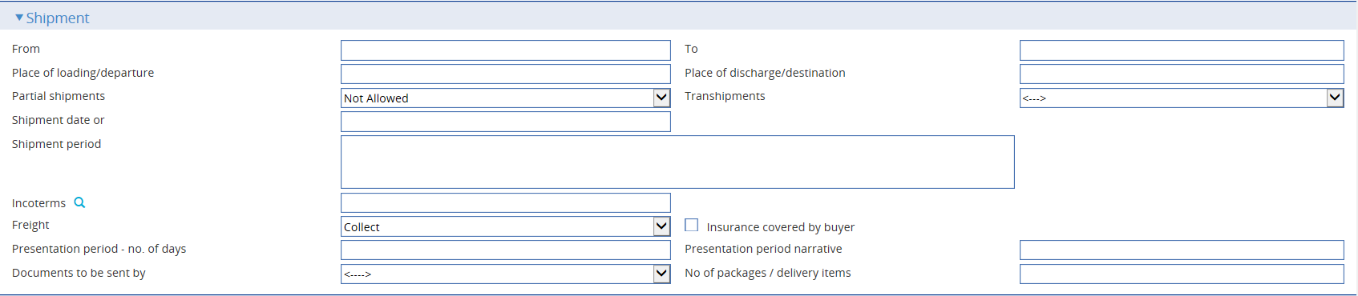

The following table explains what to enter into the fields in the Shipment pane:

|  |  |  |
| --- | --- | --- |
| Field | What to Enter | |
| From | The place of taking in charge of the goods. | |
| To | The final destination of the goods. | |
| Place of Loading/ Departure | The port or airport where the goods were loaded. | |
| Place of discharge/destination | The port or airport for which the goods are destined. | |
| Partial Shipments/ Transhipments | Select from the following values: | |
|  | Blank | To leave the field blank in the associated SWIFT message. |
|  | Allowed | If partial shipments/transhipments are permitted for this letter of credit. |
|  | Not Allowed | If partial shipments/transhipments are not permitted for this letter of credit. |
|  | Conditional | If selected then the user should specify conditions in the Additional conditions narrative. |
| Shipment Date | The latest shipment date allowed. | |
| Shipment Period | Specify the period of time during which goods are to be loaded or despatched. | |
| Incoterms | Select incoterms. | |
| Freight | When you select a value in the Incoterms field, the system automatically selects the appropriate value in this field using information set up for the selected incoterms to indicate whether freight is to be pre-paid or paid on collection. You can override this value. | |
| Insurance for Buyer | When you select a value in the Incoterms field, the system automatically selects the appropriate value in this field using information set up for the selected incoterms to indicate whether the buyer is to provide insurance cover or not. The field is checked if insurance cover is to be provided by the buyer. You can override the value displayed here. | |
| Presentation Period/Presentation Period Narrative | Specify the number of calendar days after the date of shipment within which the documents must be presented for payment, acceptance or negotiation. Narrative must only be used to specify another type of date than a shipment date, for example invoice date, from which the period for presentation begins.  A default value is set automatically; calculated using the latest shipping date and the expiry date, but this default can be overridden. | |
| Documents to be Sent By | The method to be used to send documents. | |
| Number | Specify how many mailings (up to three) are to be made. | |

#### The Goods Pane

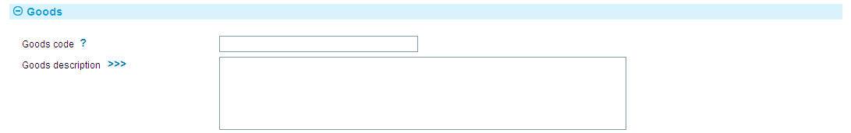

The following table explains what to enter into the fields in the Goods pane:

|  |  |  |
| --- | --- | --- |
|  | Field | What to Enter |
|  | Goods Code | Select a goods code. This field is for analysis purposes. |
|  | Goods Description | A narrative description of the goods being shipped. |

#### The Instructions Pane

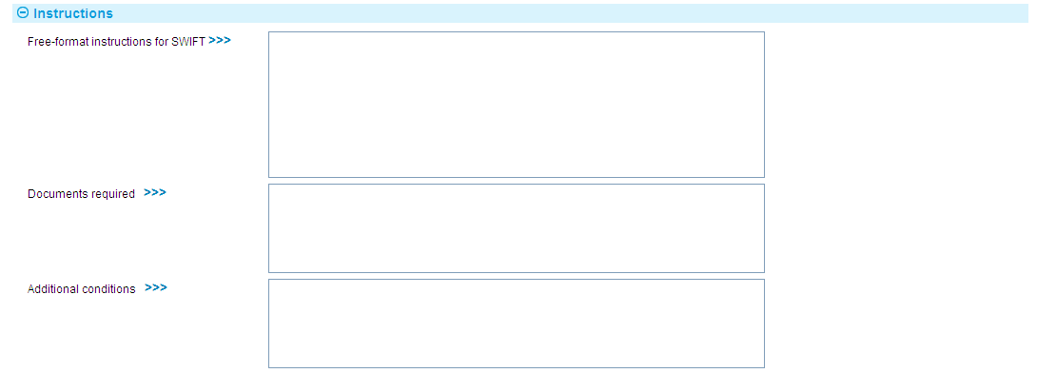

The following table explains what to enter into the fields in the Instructions pane:

|  |  |
| --- | --- |
| Field | What to Enter |
| Free Format Instructions for SWIFT | If the standby letter of credit is to be advised via SWIFT, the contents of this field will be placed into either a SWIFT MT700 or a SWIFT MT799 message, depending on whether you checked the Use Free Format field in the Main input window or not. |
| Documents Required | A narrative description of documents required. |
| Additional Conditions | Any additional conditions. |

#### The Special Payment Conditions Pane



The following table explains what to enter into the fields in the Special Payment Conditions pane:

| Field | What to Enter |
| --- | --- |
| Special payment conditions for beneficiary | Specify special payment conditions applicable to the beneficiary of the credit. |
| Special payment conditions for bank only | Specify special payment conditions applicable to the receiving bank of the credit without disclosure to the beneficiary. |
| Special payment conditions for bank only (send to next bank) | Specify special payment conditions applicable to the next advising bank / advise through bank of the credit without disclosure to the beneficiary. |

Delivery of undertaking

Beneficiary

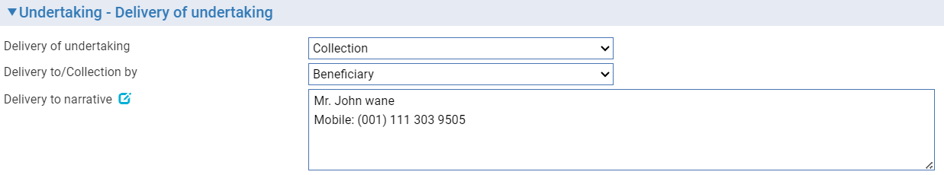

Other addressee

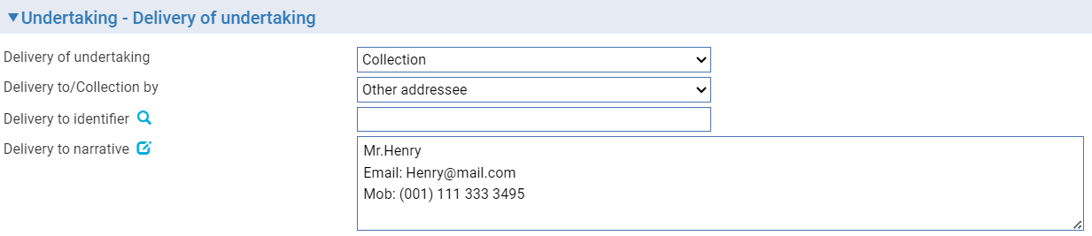

The following table explains what to enter into the fields in the Contract Details pane:

|  |  |
| --- | --- |
| Field | What to Enter |
| Delivery of undertaking | Enter the method to be used to deliver the standby letter of credit. Select either   * Collection * Courier * Mail * Message - hand deliver * Other method * Registered Mail or Air Mail |
| Delivery to/Collection by | Select either   * Beneficiary * Other addressee – this allows entry of the details of the party to whom the standby letter of credit is to be delivered/collected by |
| Delivery to identifier | Available where selection to the field ‘Delivery to/Collection by’ is “Other addressee”. Allows the user to search the party and when selected shall populate into the ‘Delivery to narrative’ field. |
| Delivery to narrative | Allows the user to enter the delivery instructions that could include the Party name, address and other related instructions. |

#### The Charges Details Pane

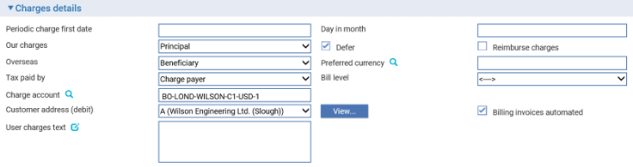

The following table explains what to enter into the fields in the Charges Details pane:

| Field | What to Enter |
| --- | --- |
| Periodic Charge First Date | The date periodic charges are first to be taken. If charges are taken in advance, enter the date on which charges are next to be taken. |
| Day in Month | The date on which charges are to be debited each month. |
| Our Charges | Select whether the charges are to be paid by the principal or the beneficiary, then press Refresh. |
| Defer | Indicate whether your own charges are to be collected now or deferred until payment. Check this box if the charges are to be deferred, otherwise leave it blank. |
| Overseas | Specify which party - the beneficiary (the default) or the applicant - will pay overseas charges. |
| Preferred Currency | Specify the currency in which the applicant's charges will be collected. Typically, you would set this to your local currency. If you leave this field blank, the system uses the currency of the transaction. |
| Tax Paid By | Specify which party - the party liable for charges (the default) or your customer - will pay any tax due on charges on the standby letter of credit. |
| Bill Level | Select whether charges for this standby should be billed at customer level, transaction level or product level. The Bill level list field excludes user defined level. |
| Charge Account | The account to be used to fund the charges. |
| Customer address (debt) | The charge payer customer’s address defaults to their prime address. The customer’s alternative address can be selected using the list field.   1. This list excludes the customer’s prime and SWIFT address types. Use the adjacent View button to display the chosen address in full. |
| Billing invoices automated | This check box can be used to indicate whether the invoices for charges generated by the transaction (e.g. Billing settlement event) are automatically generated or not. |
| Charge Text | Any additional information concerning the charges. |

#### The First Renewal and Rolling Renewal Panes

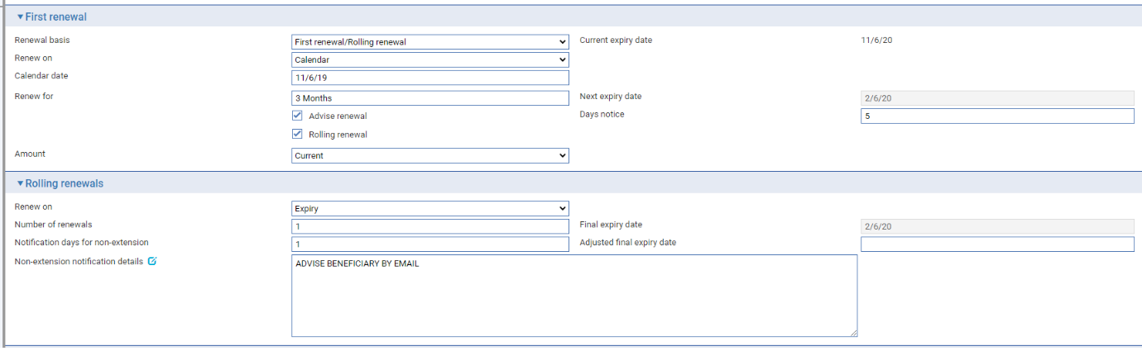

The fields in the First Renewal pane allow you to specify schedules for renewal. The fields in the Rolling Renewal pane are used to enter additional information for rolling renewals.

The following table explains what to enter into the fields in these panes:

| Field | What to Enter |
| --- | --- |
| Renew On | Select whether the standby letter of credit is to be renewed on expiry or on a calendar date. Then press Refresh. |
| Calendar Date | If you select 'Calendar' in the Renew On field, enter the date on which the standby letter of credit is to be renewed. |
| Renew For | The renewal period. |
| Next Expiry Date | The system calculates and displays the next expiry date. This date cannot be overwritten. |
| Advise Renewal | If the parties are to be advised of the renewal, check this box, then enter a figure into the Days Notice field to indicate how soon before the renewal an advice notice is to be produced for them. |
| Rolling Renewal | Check this box if the renewal is a rolling renewal, meaning that it will be renewed more than once. The following additional fields appear: |
| Amount | Select 'Original' if the standby letter of credit is to be renewed using the original amount; and 'Current' if it is to be renewed at the available amount at the time of the renewal. If you select 'Original', then any margin deposit amount is also increased to its original value. |
| Renew On | Select 'Expiry' if renewal is to occur automatically on expiry of the standby letter of credit. Select 'Every' if renewal is to occur periodically, then press Refresh. In the fields that appear specify the period. |
| Frequency | The frequency with which the renewal is to take place. |
| Day in Month | If the frequency is monthly or longer, specify the day of the month on which the renewal should take place. |
| Number of Renewals | Enter a figure to indicate how many times the standby letter of credit is to be renewed. This information is mandatory and the default is 1. |
| Cancellation Notice | The number of days notice the customer is to be given of cancellation of the rolling renewal. |
| Projected Final Expiry Date | The system displays the final expiry date based on the renewal details entered in the advise event of an export standby LC.  The system calculates and displays the projected final expiry date based on the final renewal details. This date cannot be overwritten. |
| Adjusted Final Expiry Date | You can define the final expiry date of the standby LC using this field. The expiry date defined by a Misys Trade Portal user is also displayed here.  The projected final expiry date of the final renewal can be altered by entering a date into the adjusted final expiry date. |

#### The Reduction/Increase Pane



The fields in the Reduction/Increase pane allow you to specify schedules for reductions and increases. Reductions/increases can be regular or irregular, and the fields used to define them differ accordingly. If the applicant is to be advised of any reductions or increases, check the Advise Reduction/Increase box and enter the number of days notice to be given in the Days Notice field.

For regular reductions/increases, select 'Regular' in the Select Options field and press Refresh.

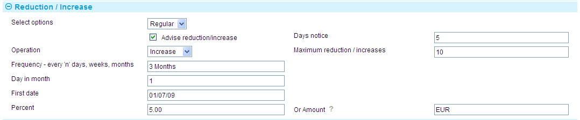

The Regular Reduction/Increase pane is displayed. The following table explains what to enter into the fields in this pane:

|  |  |
| --- | --- |
| Field | What to Enter |
| Operation | Select whether the amount is to be reduced or increased. |
| Maximum Reduction/Increases | If you selected Increase in the previous field, specify here the maximum number of increases that are to be allowed. |
| Frequency | The frequency at which the reduction/increase is to take place. |
| Day in Month | If the frequency is monthly or longer, specify the day of the month on which the reduction or increase will take place. |
| First Date | The system calculates the date of the first reduction/increase and displays it here.  If you left the Frequency field blank, for example if there is to be a single reduction/increase, then you can enter the date on which the reduction/increase is to take place here. |
| Percent/Or Amount | Specify the amount of each reduction/increase. You can specify this as a percentage of the original amount of the transaction, or as an amount. |

For irregular reductions/increases, select 'Irregular' in the Select Options field and press Refresh.

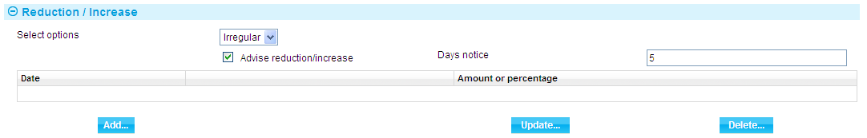

Press the Add button in the Irregular Reduction/Increase pane.

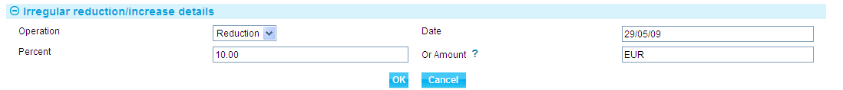

Use the fields in this window to specify in turn each of the reductions/increases that are to take place and their date and amount.

Use the Operation field to select whether the guarantee is to be reduced or increased. Use the Date field to enter the date the first reduction/increase will take place. Use either the Percent field or the Or Amount field to specify the amount by which the guarantee is to be reduced/increased.

When you close this window, the reductions/increases specified are listed in the Irregular Reduction/Increase pane, where you can amend and delete them in the usual way.

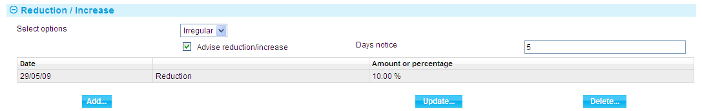

#### The Other Details Pane

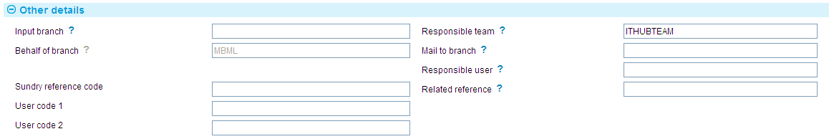

The following table explains what to enter into the fields in the Other Details pane. This pane may also include input fields defined by your bank:

|  | Field | What to Enter |
| --- | --- | --- |
|  | Input Branch | The input branch for the transaction. The input branch is set from either:   * the accounting branch from the user’s team, or * the transaction branch for user if the user has a default transaction branch or is locked to a specific branch, or * a branch associated with the user where the user can enter transactions for several branches for a team |
|  | Behalf Of Branch | The behalf of branch for the transaction as entered by the user or set from the incoming SWIFT or gateway message. The behalf of branch determines the parameter sets that are to be used to generate charges, documents, postings, etc. during transaction processing. The branch can be changed to any other branch within the same main banking entity that shares the same parameter sets. |
|  | Sundry Ref Code /User Code 1/ User Code 2 | You may use these fields to enter values for analysis purposes. Your bank will have devised its own system for using these fields. |
|  | Responsible Team | The team that has overall responsibility for the master e.g. as the contact to resolve any queries or issues regarding the master and associated events. The system defaults the responsible team when creating the transaction as follows:   * Manual – set from team creating the transaction * Gateway – set from the team specified on the incoming message (if present and valid) otherwise to the team to which the transaction is assigned through workflow allocation based on the behalf of branch * SWIFT – set to the team to which the transaction is assigned through workflow allocation based on the behalf of branch   It can be changed, if required, to either the team associated with the primary customer, default team for the product or the user’s current team. |
|  | Mail To Branch | The mail to branch can be set to any branch within the main banking entity of the behalf of branch. |
|  | Responsible User | A user that has responsibility for the master e.g. as the contact to resolve any queries or issues regarding the master and associated events. This can be any user assigned to the responsible team. |
|  | Related Reference | You can specify any other transaction to which this letter of credit is related. This may already have been done when the master record was created. You can use the browser to select from possible references to include. |

#### The Other Parties Pane

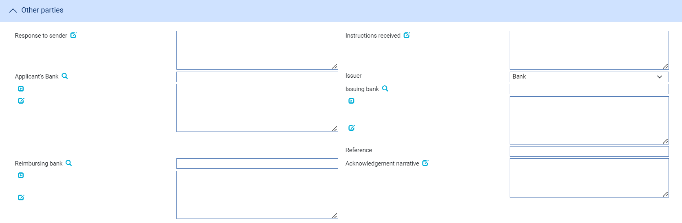

The following table explains what to enter into the fields in the Other Parties pane:

|  |  |
| --- | --- |
| Field | What to Enter |
| Applicant's Bank | The applicant's bank. |
| Issuing Bank | The issuing bank. |
| Reference | The issuing bank's reference for the standby letter of credit. |
| Reimbursing Bank | The reimbursing bank. |
| Instructions Received | Any instructions received. |

## The Export Standby Letter of Credit Master Summary Window

Once you have created an export standby letter of credit, the system will display the basic details of the standby letter of credit using the Master Summary window.

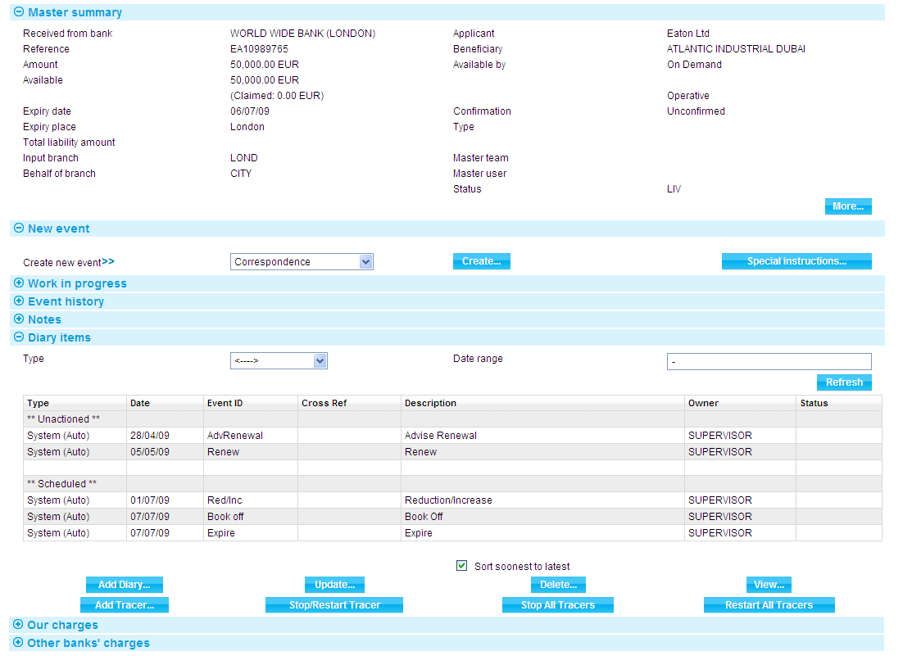

For more information on how the various panes and buttons in this window work see the Common Facilities User Guide – Trade Innovation.

# Acknowledgement

This chapter explains how to use the system to handle acknowledgement of a standby letter of credit.

## Acknowledgement in Trade Innovation

You can use the Receive Acknowledgement event to view details of an acknowledgement you have received, or enter details of an acknowledgement to be sent. You can create either a response to that message or a new message within the same event.

If your bank receives an acknowledgement via SWIFT, it uses it to create a Receive Acknowledgement event at an Input step for the appropriate guarantee.

To record an acknowledgement message, in the Master Summary window select 'Receive Acknowledgement' from the Create New Event drop-down list. The system opens the event at either a Log step or Input step. Depending on how your system is configured, panes and fields available in log steps can be tailored for each data capture step. See the *SDK - Screen Tailoring User Guide* for details.

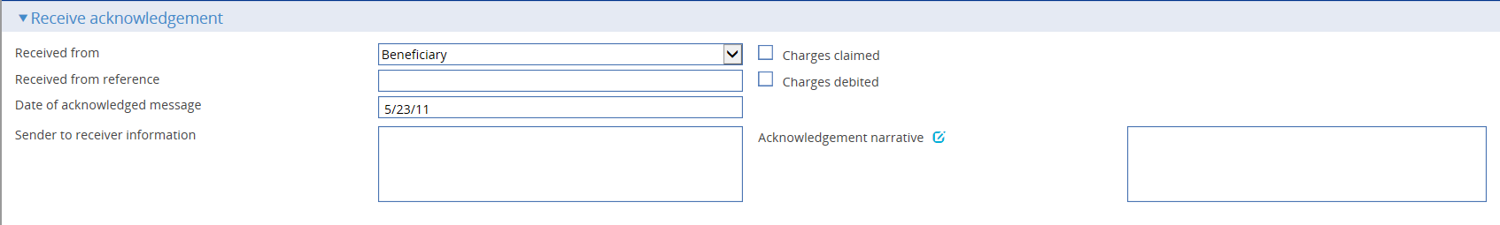

The default for the Received From party is the beneficiary.

Use the Received From Reference field to enter the Received From party's reference for the guarantee and the Sender to receiver information and Acknowledgement narrative fields to enter any narrative associated with the response. The Charges Claimed and Charges Debited boxes permit you to indicate, if appropriate, whether the advising bank is claiming or has debited its charges. You cannot check both of these boxes, but you can leave them both blank.

Use the Date Received field to enter the date your bank received the acknowledgement.

# Paying an Export Standby Letter of Credit

This chapter explains how to use the system to record the presentation of documents and to select the required payment action for an export standby letter of credit, including continuing claims that are left unpaid as a result of requesting payment. It also explains how to enter details of additional amounts, margin deposits and assignments of proceeds against payments.

For information on payment actions, including additional bank defined actions and their effect on charges see the Appendix.

For information on repaying a financing loan from within a payment event see the Financing User Guide – Trade Innovation.

## Payment in Trade Innovation

When the beneficiary or bank presents documents for payment, the system includes a Documents Presented event (see page 25) that allows you to proceed in various ways, depending on the state of the documents presented:

If the documents are in order, you can either make the payment or request payment, then send the documents presented and details of any payment made to the issuing bank. Where there is a reimbursing bank, a claim for reimbursement can be sent to the reimbursing bank.

If there are discrepancies in the documents:

* You can advise the presenting party that this is the case, and then request missing documents or return the documents to the presenting party and request re-presentation
* You can request authority from the issuing bank to make payment. When the issuing bank replies you can proceed with the payment, refuse it, or reject it, depending on whether authority has been given or not. The Outstanding Presentation event (see page 34) allows you to continue a claim that has been pended in this way
* If the discrepancies are only minor, you can pay the beneficiary, with the caveat that, should the documents be refused by the issuing bank that the payment will be recoverable from the presenting party

A standby letter of credit may have more than one Documents Presented event, and each Documents Presented event may have a history of several Outstanding Presentation events associated with it. However, only one event can be in progress for each presentation at any one time.

The system allows documents to be presented for full or partial payment, depending on whether these are permitted under the standby letter of credit. Where a part payment is made, the system reduces the outstanding amount of the standby letter of credit by the value of the part payment; the remaining amount is then available for subsequent presentations.

If the standby letter of credit is participated, payment may result in a Drawdown/Revolve Commit Amt event being created as a subsidiary event to increase the commitment amount available on the participation deal, if the deal is revolving.

### Assignment of Proceeds

During payment events the system permits you to set up new assignments for the transaction, and to access details of assignments already set up and allocate proceeds to them.

Each payment amount allocated to an assignment can be discounted as part of the payment event, if required. However, it cannot be discounted later, once the payment event has completed.

### Licenses

If there is a license attached to a revolving transaction, the license amount must be sufficient to cover the maximum amount available under the transaction - that is, the transaction amount plus the maximum tolerance - multiplied by the number of revolving cycles.

See the Licenses User Guide – Trade Innovation for details of licenses.

### Financing Transaction

If your system has the financing module implemented, then while processing a payment the Finance pane will be available.

This allows you to record a financing transaction against the payment, as described in the Financing User Guide – Trade Innovation.

You can also repay a financing transaction from within the payment event.

## Payment at Maturity

For claims whose payment action was ‘Pay at Maturity’ or ‘Accept’ the system creates an outstanding payment event in the diary to handle the payment at the time of maturity. When the maturity date is reached the system processes the event during overnight processing. The event may require input or review and/or authorisation, in which case the system places the event in the Work in Progress pane for you to complete.

When you open an outstanding payment event for a maturity payment the system displays the relevant ‘Maturity’ response type.

## Document Presentation

To record the presentation of documents for an export letter of credit, in the Master Summary window select 'Documents Presented' from the Create New Event drop-down list. The system opens the event at either a Log step (see page 25) or Input step (see page 26), depending on how the Workflow orchestration controlling the event is configured. See the *Workflow Tailoring User Guide* – Trade Innovation for details.

### Logging the Presentation

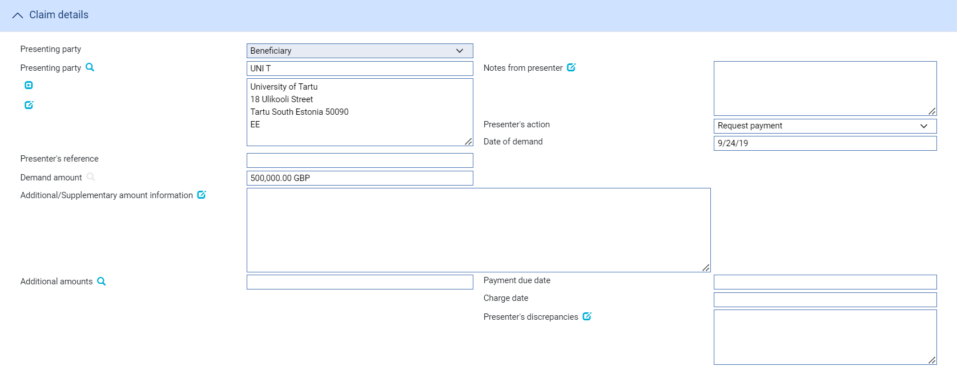 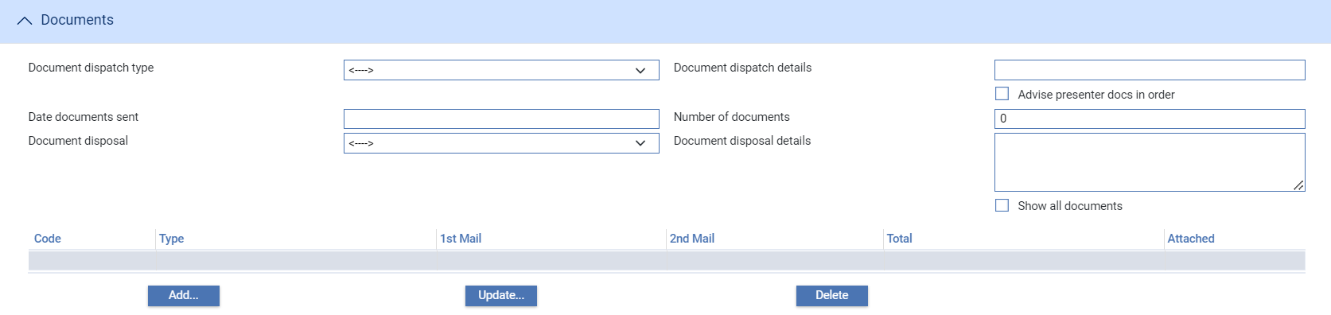

The table below lists the fields shown in a Log window and explains what to enter into them. For instructions on using the fields in the Documents pane to identify any documents being presented see the Common Facilities User Guide – Trade Innovation.

|  |  |
| --- | --- |
| Field | What to Enter |
| Presenting Party Type | Select the role of the presenting party. This will default to the party the letter of credit was advised to. |
| Presenting Party | The presenting party. You can use the first field to select a party already identified in the event using their party role, in which case their details are retrieved and displayed in the remaining fields in this pane.  Alternatively, if the presenting party has not been assigned a party role within the transaction, select 'Other presenting party' in the first field, then use the remaining fields to enter their details in the usual way. If you identify a party in this way, they are assigned the role of 'Presenting party'.  The system uses the advising bank as the default, or the beneficiary, if the letter of credit was advised direct. |
| Presentation Amount | The amount being claimed. |
| Presentation Date | The date the documents were presented. The system uses today's date as the default. |
| Presenter's Reference | The presenting party's reference for the presentation of documents and request for payment. |
| Date Documents Sent | The date the documents were sent by the presenting party. |
| Number of Documents | The number of documents being presented. In the table you can enter details for each of the documents presented to support payment. |

### Entering Full Details of the Presentation

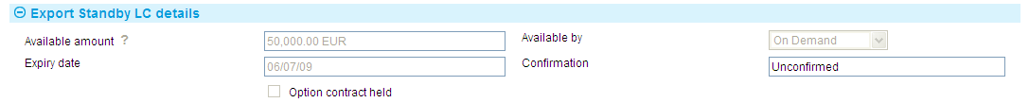 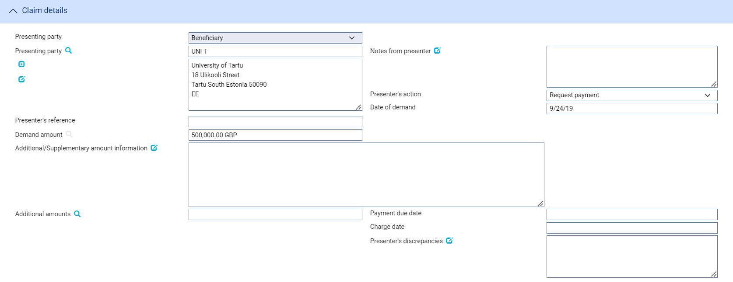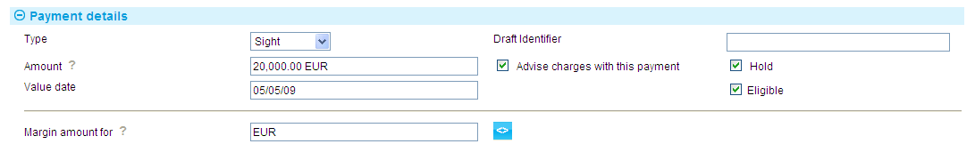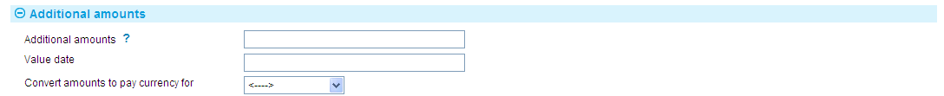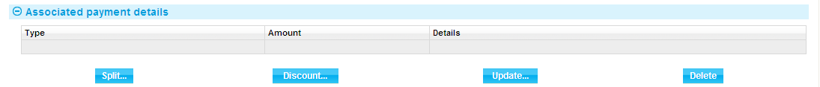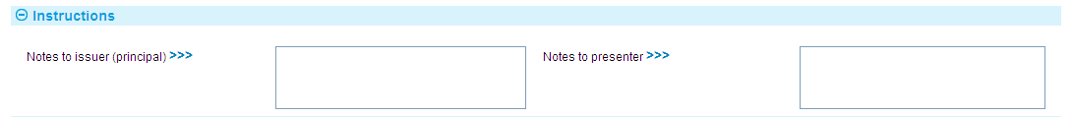 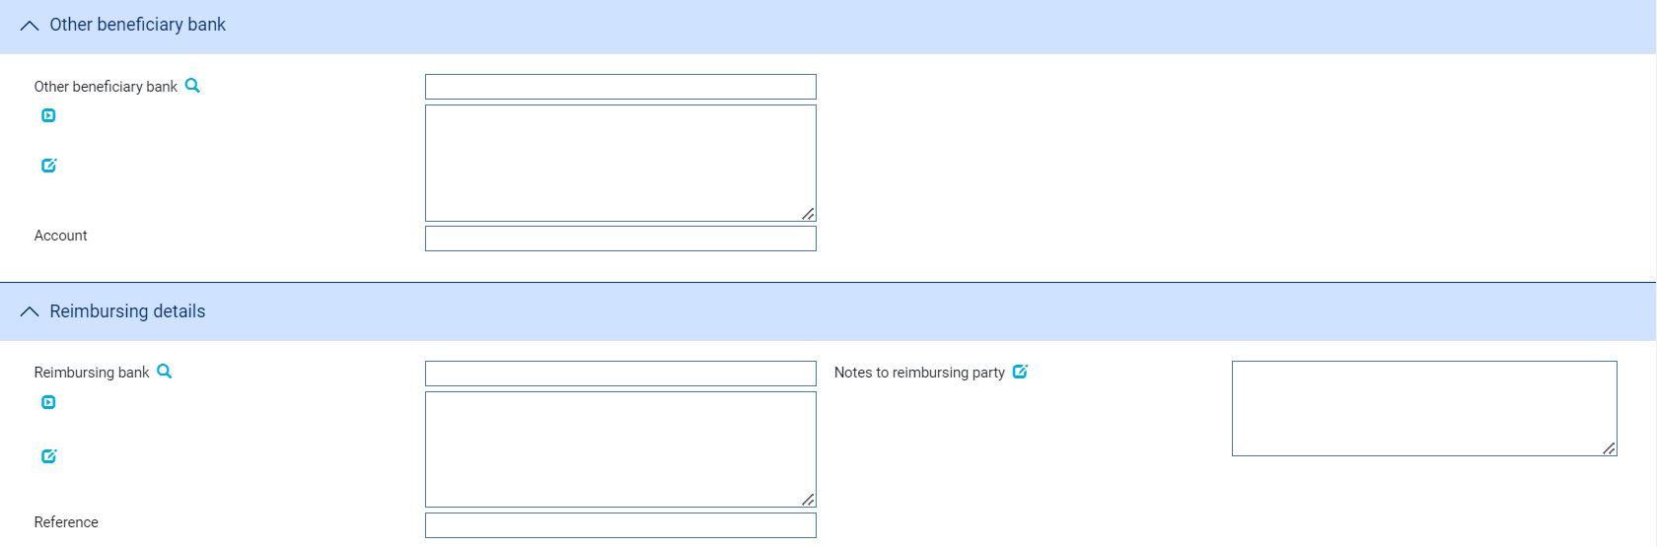

An Input step uses the following panes:

* The Export Standby LC Details pane (see page 31)
* The Claim Details pane (see page 31)
* The Payment Action pane (see page 32)
* The Payment Details pane (see page 33)
* The Associated Payment Details pane (see page 36)
* The Additional Amounts pane (see page 35)
* The Instructions pane (see page 36)
* The Documents/Notes pane
* The Export Standby LC Details pane
* The Other Beneficiary Bank pane (see page 36)
* The Reimbursing Details pane (see page 37)

For instructions on using the fields in the Documents/Notes pane to identify any documents being presented see the Common Facilities User Guide – Trade Innovation.

#### The Export Standby LC Details Pane



This provides some of the key details relevant to payment of the letter of credit – read only.

#### The Claim Details Pane

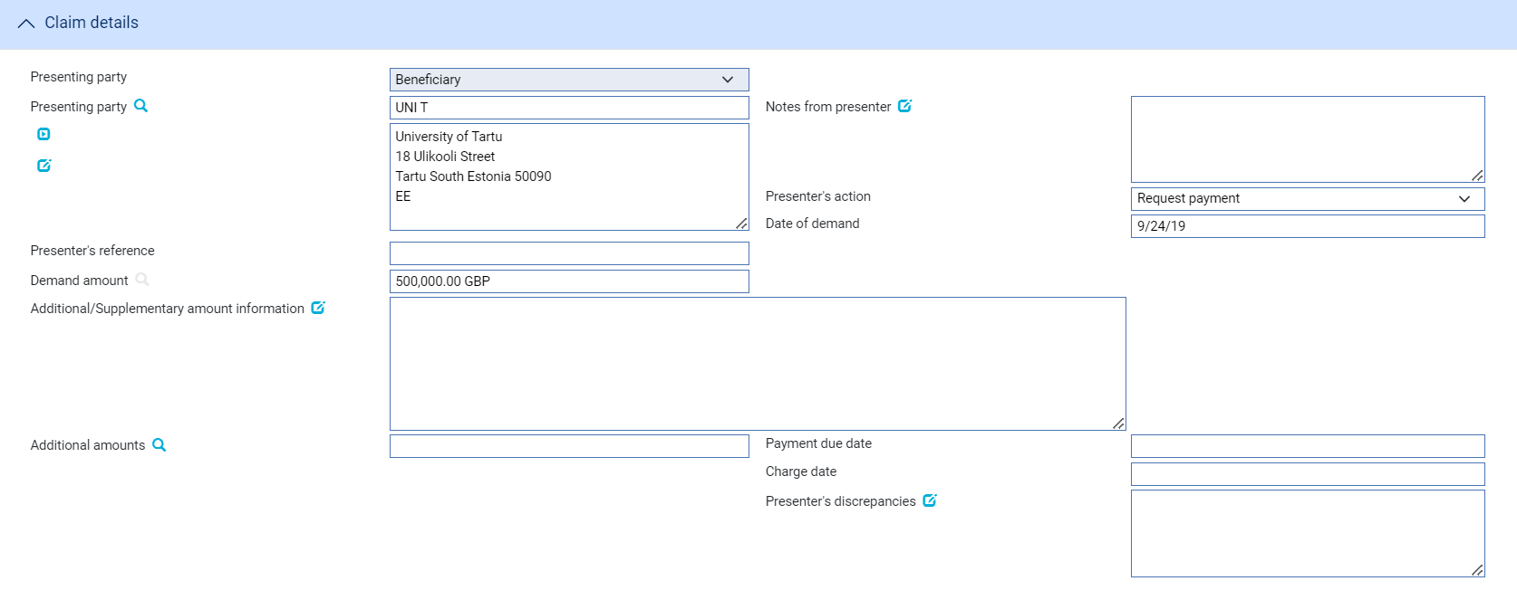

The following table explains what to enter into the Claim Details pane:

|  | Field | What to Enter |
| --- | --- | --- |
|  | Presenting Party | The presenting party. You can use the first field to select a party already identified in the event using their party role, in which case their details are retrieved and displayed in the remaining fields in this pane.  Alternatively, if the presenting party has not been assigned a party role within the transaction, select 'Other presenting party' in the first field, then use the remaining fields to enter their details in the usual way. If you identify a party in this way, they are assigned the role of 'Presenting party'.  The system uses the advising bank as the default, or the beneficiary, if the letter of credit was advised direct. |
|  | Notes from Presenter | Any notes or instructions received from the presenting party. |
|  | Presenter’s Action | Choose one of the following values from the drop-down list to indicate what action the presenter has taken with regard to the claim:   * Request Authorisation to Pay * Pay and Claim Reimbursement * Request Payment * Request Acceptance * Sender has Debited our Account * Documents Sent On Approval * Other |
|  | Presentation Date | The date of the presentation. The system uses today's date as the default. |
|  | Presenter's Reference | The presenter's reference for the letter of credit. |
|  | Presentation Amount | The system displays either the available amount of the letter of credit (less any outstanding claims) or the presentation amount, if entered during a Log step. |
|  | Presentation Currency | The currency of the presentation amount, if different from the currency of the letter of credit. |
|  | Additional Amounts | Any additional amounts being claimed. |
|  | Payment Due Date | The date payment is due, or the value date used to debit your account with the presenting bank. |
|  | Charge Date | The value date for any charges taken separately. |
|  | Presenter’s Discrepancies | Details of any discrepancies. |

#### The Payment Action Pane



The Payment Action pane allows you to process the claim by selecting a payment action and then entering details of the payment.

The actions included in the Current Option drop-down list vary, depending on whether the standby letter of credit was a direct presentation by the beneficiary, and on the presenter's actions, for example whether they are requesting authorisation to pay or whether instead they have paid and are requesting reimbursement.

For a single payment, details of the actual payment are entered into the Payment Details pane. If payment is mixed, to involve two or more part payments, check the Mixed Payment field, then press the Refresh button. The system displays a Payments pane, which you can use to enter details of each of the part payments in turn.

Check the With Recourse box if the payment is with recourse; and the Final Payment box if the payment includes the final payment under the reimbursement authority.

If your payment action is 'Reject and Claim Refund', press Refresh and then enter the date of the refund into the Refund Date field.

The payment action you select applies to all part payments. However, where the action is 'Pay' the individual status of a payment can be changed using the Pay Status field in the Payment Details window.

Note that:

* If you enter any part payment details, the value of all part payments must not exceed the value of the letter of credit, and must reconcile with the claimed amount
* Where the payment action for an individual part payment is 'Pay at Maturity' or 'Accept', the system creates a diary event which will cause an Outstanding Claim event to be generated automatically at the appropriate time to allow that part payment to be matured
* If the payment action is 'Pay' for an acceptance or deferred payment, the system generates the postings and funds movements for the future date, and no separate future Outstanding Claim event takes place. The forward-dated postings are held by the system until the value date is reached, then posted during batch processing
* If the payment action is 'Request Approval from Issuing Bank', the system displays an additional field - Reasons for Authorisation request - in the Instructions To Send pane

1. The system is delivered with a standard set of ‘Presenter’s actions’ and ‘Payment actions’ which will typically cover the required processing for claims and documentary presentations. However, depending on your bank’s internal processes and requirements, it may be necessary to create additional Presenter’s and Payment actions that are more appropriate to your workflow.

Where this is required, your bank can use System Tailoring to define its own Parameter set based Presenter's actions and Payment actions for Export standby letters of credit and additionally, create Transfer presenter's actions and Response actions as required. A code and description can be entered for each of these actions together with the associated underlying payment ‘behaviour’ type, such as *General request, Pay, Reject, or Pay at maturity* which then determines the subsequent processing of the payment when the action is selected.

See the System Tailoring User Guide – Trade Innovation for instructions on defining additional payment actions.

#### The Payment Details Pane



The Payment Details pane allows you to enter details of the payment you are making.

For mixed payment, check the Mixed Payment field in the Payment Action pane. A new pane - the Payments pane - is displayed.

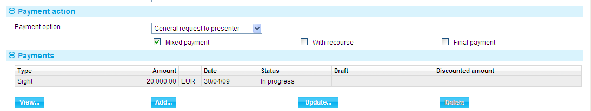

Select the payment listed in this window and press the Update button. In the window that appears, define the first part payment.

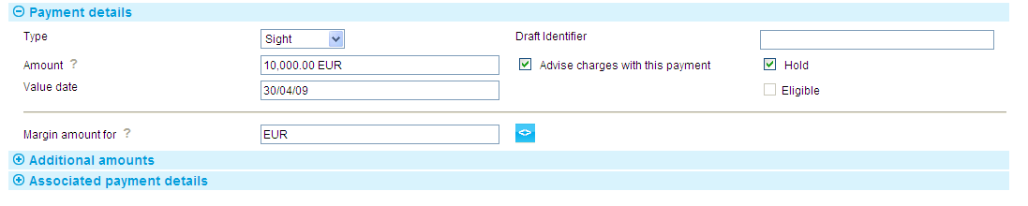

The fields are the same as those used in the Payment Details pane to define a single payment. When you close the window, the details of the part payment are listed in the Payments pane, from where you can select them and amend or delete them. Use the Add button to reopen the window to enter details of the next part payment.

Once you have entered details of a payment, or part payment, it is listed in the Payments pane.

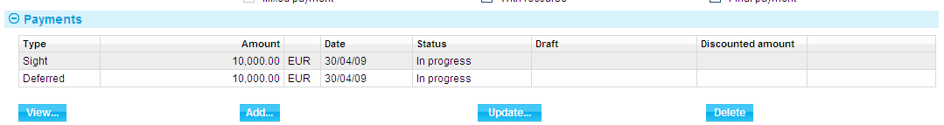

1. The system creates a first part payment for the full amount of the payment event. If you add more part payments, remember to amend the amount of this first part payment accordingly.

The following table explains what to enter to define a payment or part payment:

| Field | What to Enter |
| --- | --- |
| Payment Action | This field is displayed only for mixed payments, and it initially reflects the payment action selected for the claim in the main Input window. If the payment action involves refusal or leaves the claim outstanding, then you will not be able to alter the value in this field.  If the payment action involves paying the claim, then you can use this field to select a status for each individual part payment.  Select from the available options. |
| Type | Select the type of payment - Sight, Acceptance or Deferred - then press Refresh. The fields displayed in the rest of the window vary, depending on what you enter here. |
| Amount | The amount being claimed. |
| Advise Charge with This Payment | Check this box if charges taken or claimed are to be advised with this payment. |
| Value Date | For sight payments, enter the value date of the payment.  For acceptance and deferred payment the value date of the payment is calculated using the value in the Period field.  The system issues a warning if this date does not leave enough time for any pre-debit notification required. |
| Start Date/Period/From/ After | For acceptance and deferred payments, the start date of the payment period.  Use the Period field to define the period (as, for example, 1 month or 10 days), then use the From/After field to indicate whether the period will be calculated from or after the base date. |
| Draft Identifier | If you know the draft identifier, enter it here. |
| Hold | This field is displayed for sight and acceptance payments. Check it if drafts are being held, and uncheck it if they are being returned to the claimant.  You can discount a draft only if this and the Eligible box are checked. |
| Eligible | This box must be checked for you to be able to discount a part payment. For sight and acceptance payments, the Hold box must also be checked. |

#### The Additional Amounts Pane



The following table explains what to enter into the fields in the Additional Amounts pane:

|  |  |
| --- | --- |
| Field | What to Enter |
| Additional Amounts | Any additional amount. |
| Value Date | The value date of any additional amount. |
| Convert Amounts to Pay Currency For | The payment amount may need to be converted to a different currency for the paying bank and or the presenting party. If so, select the appropriate value - Presenting Party, Both Parties or Paying Bank - here. If you select a value in this field the additional fields listed below are displayed. |
| Rate to Convert to Payment Currency | If the payment amount needs to be converted to a different currency select or enter the rate to be used to make the conversion. |
| Additional Amounts FX | The additional amount, expressed in the currency of the reimbursement authorisation. |
| Branch | Where relevant, the branch that owns the foreign exchange deal. |
| Margin Amount For | Where relevant, the amount to be taken as a margin deposit. |

#### The Associated Payment Details Pane



The Associated Payment Details pane allows you to apply further processing against the payment or part payments being made. As payments are defined they are listed in this pane. You can select them individually and enter details of a loan or discount or license drawdown.

See Chapter 9 for instructions on using this pane to apply further processing against the payment or part payments being made.

#### The Instructions Pane

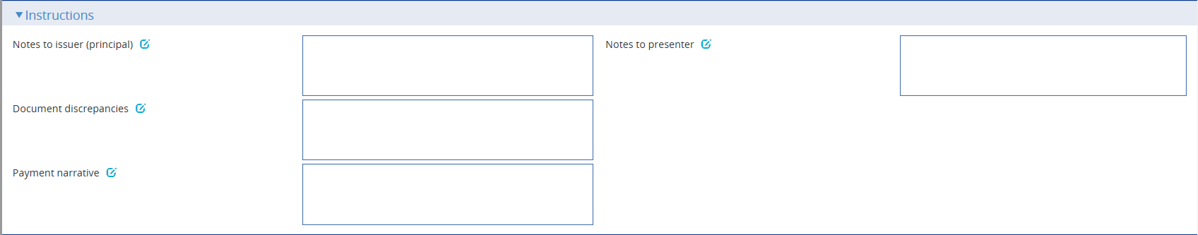

The Instructions pane allows you to enter notes for the issuer and the presenter.

Depending on the setting of the system option DiscrepancyFieldAlwaysVisible the Document Discrepancies field may be displayed here, even if the payment action would not normally require it to be populated. When the system option is switched on the field allows you to enter minor discrepancies for your bank's own audit purposes, where the payment action does not normally involve reporting discrepancies.

Payment Narrative field is displayed when payment action is set to Pay, Pay and claim reimbursement, Pay at maturity, Pay with discrepancies, Pay with financing, Accept or Approve Authorisation Request.

#### The Other Beneficiary Bank Pane

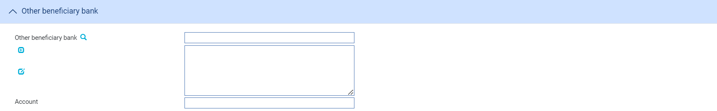

The fields in the Other Beneficiary Bank pane allow you to identify the bank you want the issuing bank to pay, if other than your own bank, and the number of the account to be credited.

#### The Reimbursement Details Pane

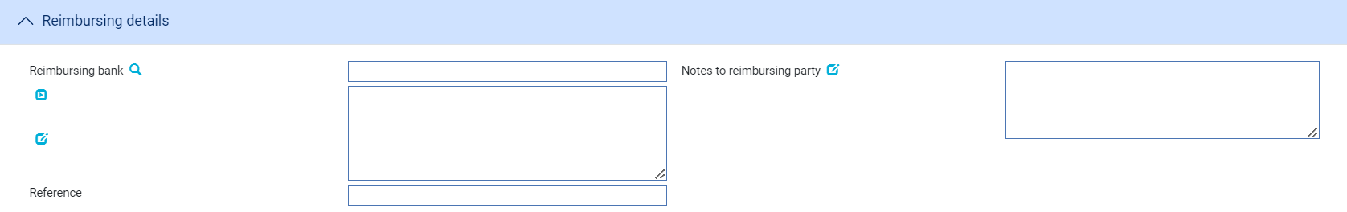

The fields in the Reimbursement Details pane allow you to identify the bank from whom reimbursement is to be requested, together with any notes for the reimbursing bank and the reimbursing bank's reference for the claim or letter of credit, if known.

## Continuing a Claim

If you select a payment action during the Documents Presented event which involves postponing payment whilst awaiting a reply, for example until you have received authorisation to pay from the issuing bank, the Outstanding Presentation event allows you to continue the claim.

To continue the claim, in the Master Summary window select 'Outstanding Presentation' from the Create New Event drop-down list. The system opens the event at either a Log step (see page 25) or Input step (see page 26), depending on how the Workflow orchestration controlling the event is configured. See the *Workflow Tailoring User Guide* – Trade Innovation for details.

### Selecting the Presentation to Continue

If there is only one outstanding claim, the system retrieves it and displays its details. If there is more than one outstanding claim, you must use the Select button to select the one to continue. When you press this button the system displays the Select Payment Event window.

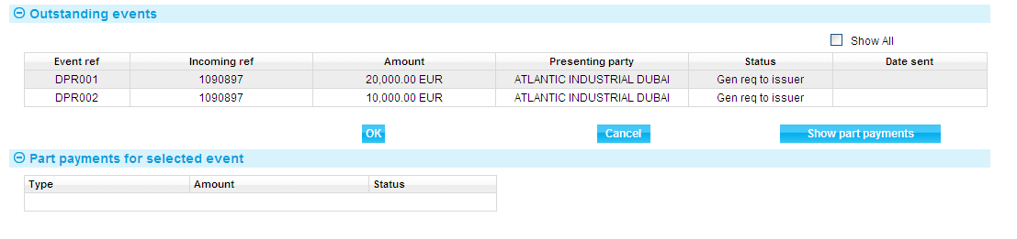

This window lists all completed Claim Received events that have not been paid. The window does not show any claims currently in progress. If you check the Show All box, the system also includes in the list all completed Claim Received and Outstanding Claim events that have been paid in full or been rejected.

If you check the Show All box, the system also includes in the list all completed payment events that have been paid in full or been rejected. You can initiate an outstanding claim event against a completed claim event in order to issue general correspondence or to reject a previously-paid claim.

You can view details of the drafts associated with a claim by selecting the event and pressing the Show Part Payments button.

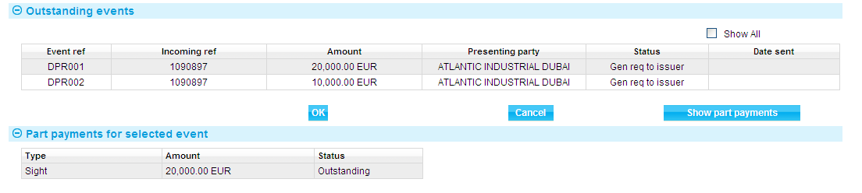

When you select an event and then press the OK button, the system closes the window and displays information taken from that event.

### Logging the Response

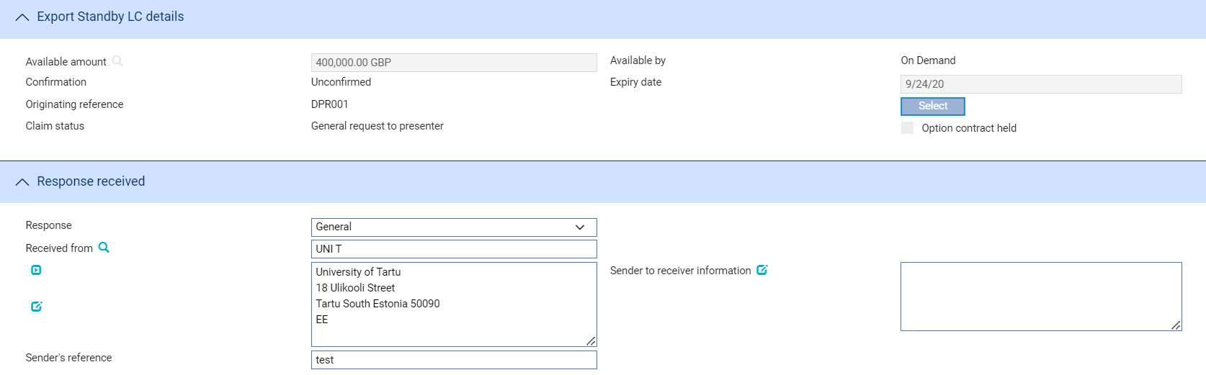

If there is only one outstanding claim, the system retrieves it and displays its details. If there is more than one outstanding claim, use the Select button to select the one to continue.

The following table explains what the fields in a Log window show:

| Field | What it Shows |
| --- | --- |
| Event Reference | The reference of the event that is being continued. |
| Presenting Party | The presenting party. You can use the first field to select a party already identified in the event using their party role, in which case their details are retrieved and displayed in the remaining fields in this pane.  Alternatively, if the presenting party has not been assigned a party role within the transaction, select 'Other presenting party' in the first field, then use the remaining fields to enter their details in the usual way. If you identify a party in this way, they are assigned the role of 'Presenting party'.  The system uses the advising bank as the default, or the beneficiary, if the letter of credit was advised direct. |
| Presenter's Reference | The presenter's reference for the original claim. |
| Amount | The amount of the claim in the original Documents Presented event, and the payment type. |
| Status | The status of the claim. |
| Date Sent | The date the original request was sent. |
| Date Received | The date the reply was received by your bank. The system uses today's date as the default. |
| Date Request Sent | The date your bank sent the message to which this is the reply. |
| Response | The type of response. You can select from the following:   * General (see page 37 ) * Documents Received (see page 37) * Advice of Discharge (see page 37) * Refusal (see page 38) * Advice of Payment (see page 41) * Authorisation to Pay (see page 40) * Invoices Received (see page 37) for transfer letters of credit * Maturity (see page 25), if the event has been generated automatically from a diary action * Reverse Payment (see page 41)   Once you have selected the response, press Refresh. The fields shown in the window vary, depending on what response type you select. |
| Received From | Details of the party from whom you received the reply. |
| Sender's Reference | The reference used by the sender for the reply. |

### Entering Full Details of the Response

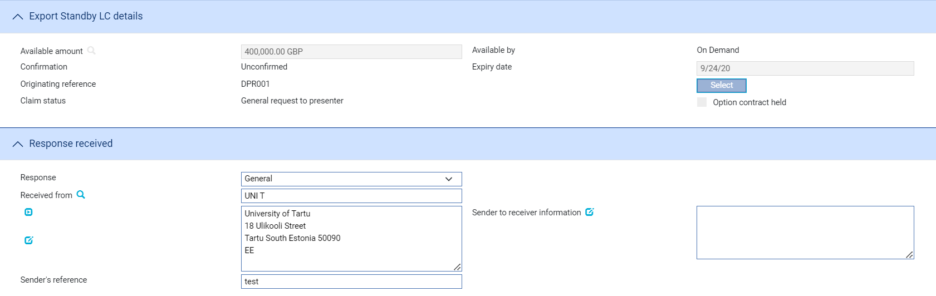 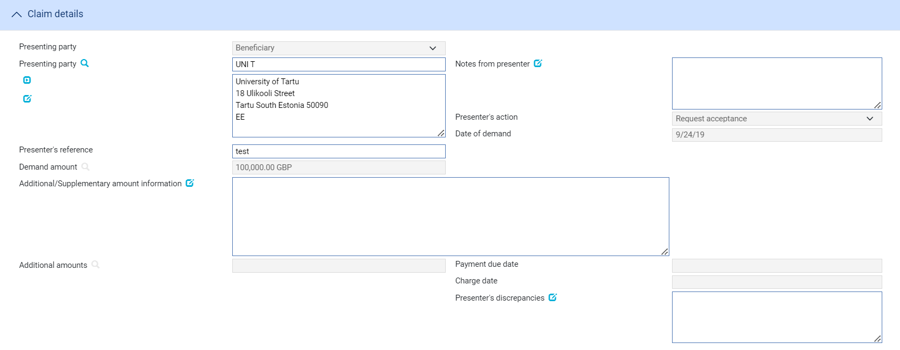 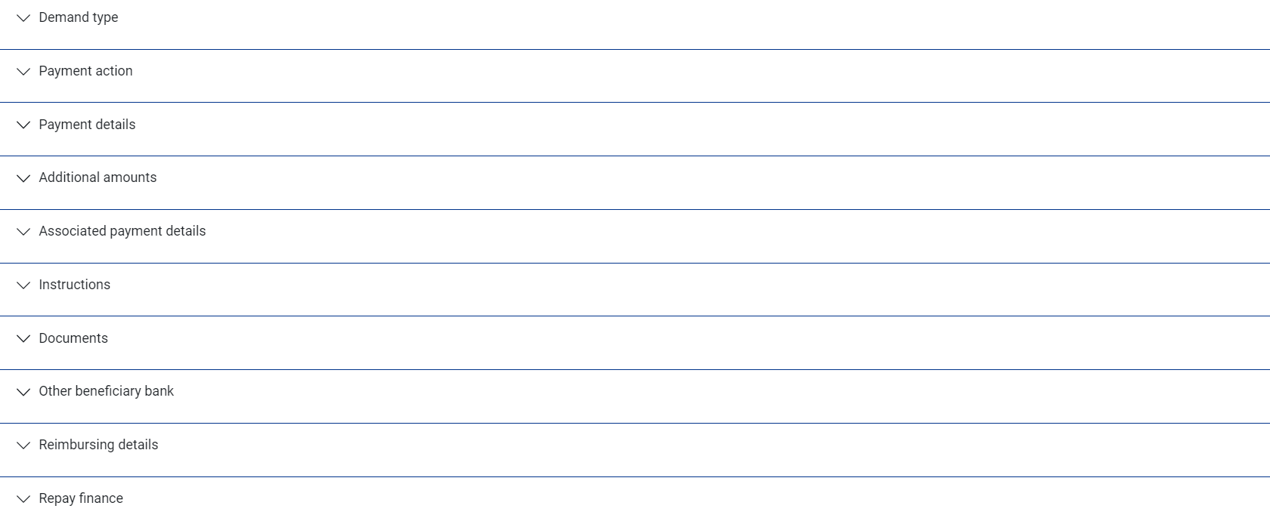

If there is only one outstanding claim, the system retrieves it and displays its details. If there is more than one outstanding claim, use the Select button to select the one to continue.

Use the Received From field to identify the party from whom you received the response, and enter their reference for the response into the Sender's Reference field.

The Response field allows you to identify the type of response received. You can select from the following:

* General (see page 37)
* Documents Received (see page 37)
* Advice of Discharge (see page 37)
* Refusal (see page 38)
* Advice of Payment (see page 41)
* Authorisation to Pay (see page 40)
* Invoices Received (see page 37) for transfer letters of credit
* Maturity (see page 25), if the event has been generated automatically from a diary action
* Reverse Payment (see page 41)

The fields shown in the window vary, depending on what response type you select.

#### General/Documents Received/Invoices Received

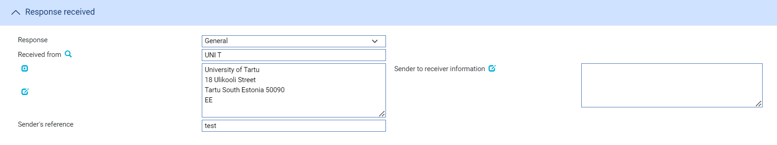

If you select 'General', 'Documents Received' or 'Invoices Received', you can use the Sender to Receiver Information field to enter any narrative from the sender. If you select 'Documents Received', you should also enter details of the documents received in the Documents/Notes pane.

#### Advice of Discharge

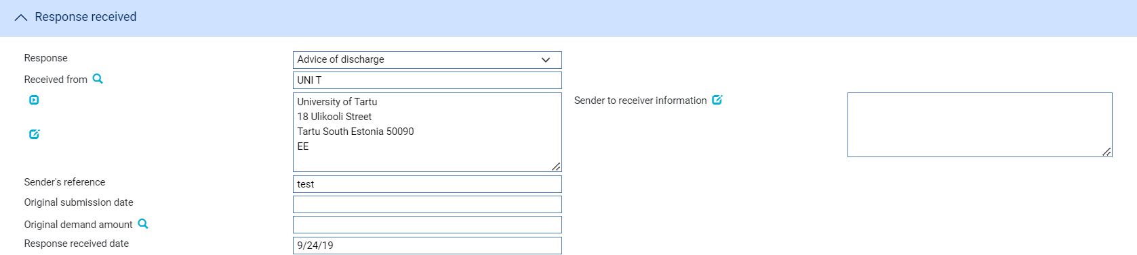

The following table explains what to enter into the fields displayed when you select 'Advice of Discharge':

|  |  |
| --- | --- |
| Field | What to Enter |
| Instructions Received | Any narrative from the sender. |
| Payment Advice Date | The date of the original payment advice. |
| Amount Originally Claimed | The amount claimed on the original payment advice. |

#### Refusal

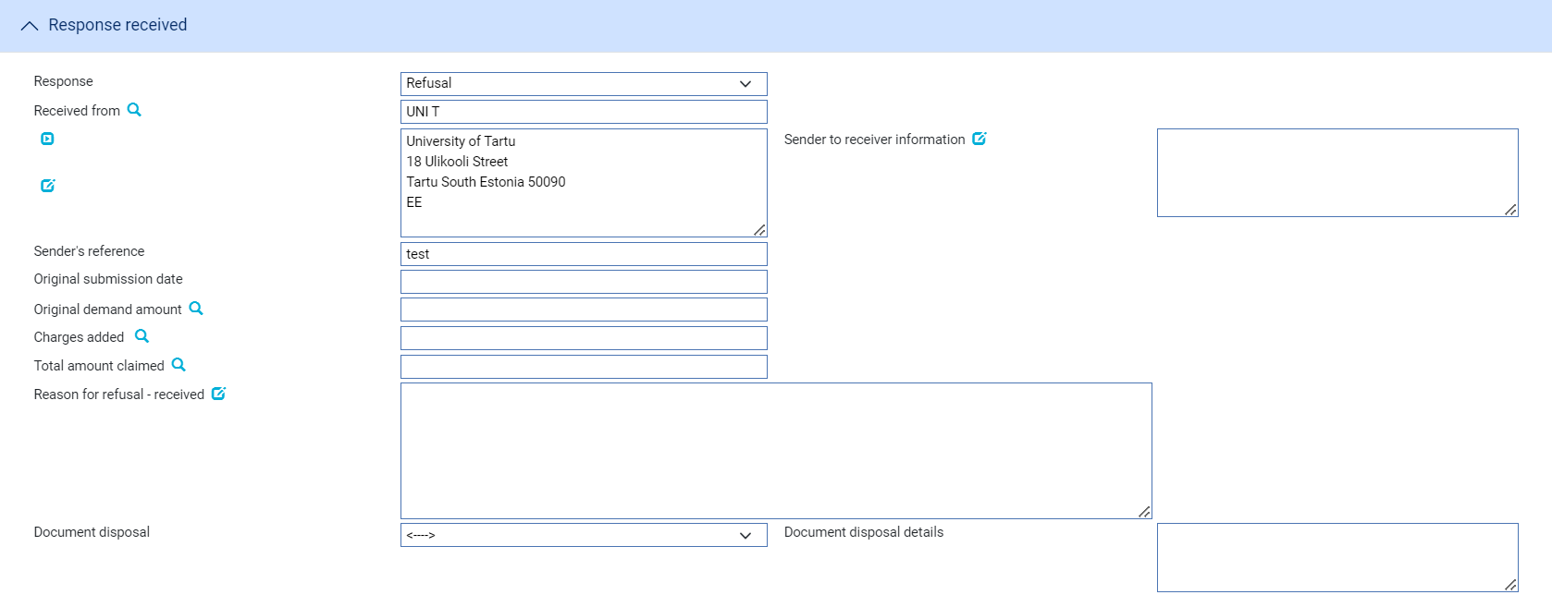

The following table explains what to enter into the fields used to record refusal:

| Field | What to Enter |
| --- | --- |
| Sender to Receiver Information | Any narrative from the sender, which can be the applicant or the applicant's bank. |
| Reason for Non-Payment | Specify the reason for non-payment.  Use one of the following options: |
|  | Different claiming bank |
|  | Duplicate claim |
|  | Insufficient information in the claim |
|  | Not authorised by Issuing Bank to reimburse |
|  | Other |
|  | Total claim exceeds maximum amount (excluding additional amounts) |
|  | Refer to Issuing Bank for further instruction |
|  | TT claim not allowed |
|  | Information stated in the claim differs from the R/A |
|  | Total claim exceeds available amount (including additional amounts) |
| Disposal of Reimbursement Claim | Specify the action taken by the Reimbursing Bank  Use one of the following options: |
|  | Claim has been cancelled. |
|  | Claim is held. |
|  | Claim has been returned. |
| Payment Advice Date | The date the original payment advice was sent. |
| Amount Originally Claimed | The amount claimed on the original payment advice. |
| Charges Added | Any charges (with currency) being claimed by the sender as the result of refusing the claim. These represent other bank's charges due from the seller. |
| Total Amount Claimed | The total amount (with currency) being claimed for refund. This is the total of the original amount plus any charges added. |
| Discrepancy Details Received | Narrative giving the reason for the refusal received from the sender. |

Use the Document Disposal field in the Documents/Notes pane to indicate what is to be done with the documents.

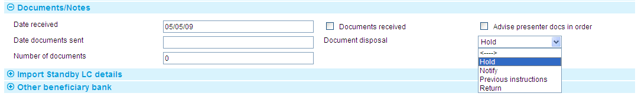

The following table explains the values of Disposal of Documents:

|  |  |  |
| --- | --- | --- |
| Field | What to Enter | |
| Disposal of Documents | Use this dropdown to indicate the disposal action for the documents. | |
|  | Hold | Select this field if you intend to hold documents received whilst awaiting further instructions from presenter/issuing bank. |
|  | Notify | Documents held until the issuing bank receives a waiver from the applicant and agrees to accept it, or receives further instructions from the presenter prior to agreeing to accept a waiver. |
|  | Previous instructions | Acting in accordance with instructions previously received from the presenter. |
|  | Return | Select this field if documents are to be returned to the sender. |

#### Authorisation to Pay

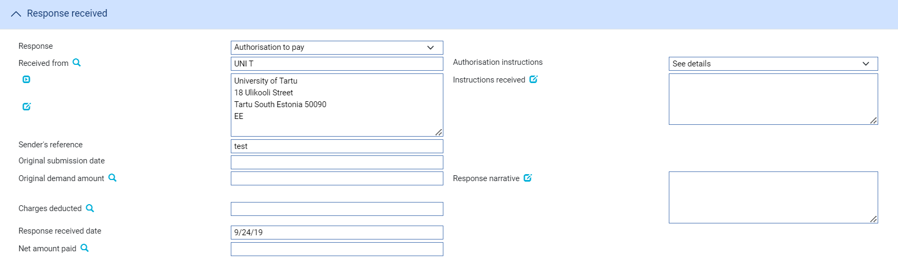 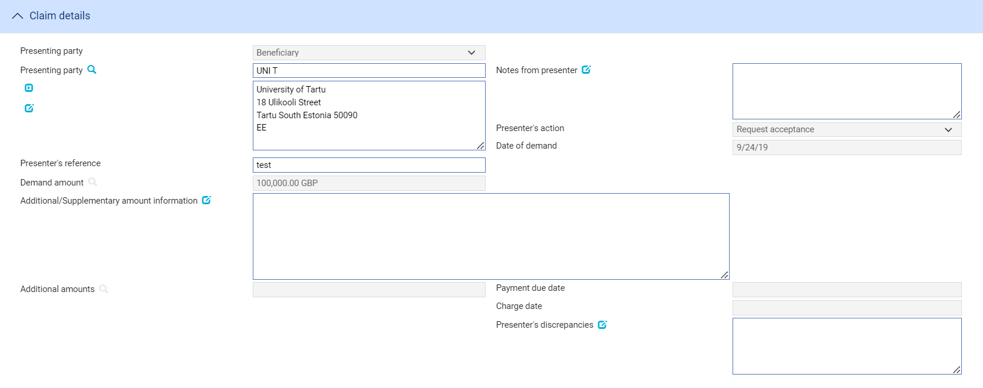

The following table explains what you should enter into the fields used to record authorisation to pay:

|  |  |
| --- | --- |
| Field | What to Enter |
| Authorisation Instructions | Select from one of the following:   * Accept * Debit Selves * Pay and Claim Reimbursement * See Details * Negotiate |
| Instructions Received | The terms of the authorisation. |
| Payment Advice Date | The date of the original payment advice. |
| Amount Originally Claimed | The amount claimed on the original payment advice. |
| Charges Deducted | Any charges being deducted by the sender.  For complete reconciliation check this amount using the Charges Summary window. See the Common Facilities User Guide – Trade Innovation for instructions. |
| Response Narrative | Narrative from Sender. |
| Net Amount Paid | The net amount being paid. |

#### Advice of Payment

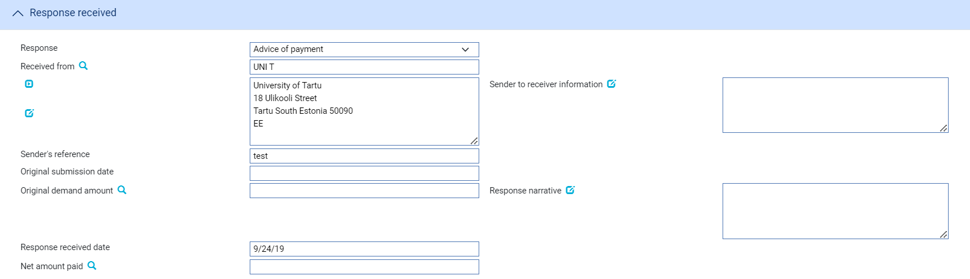 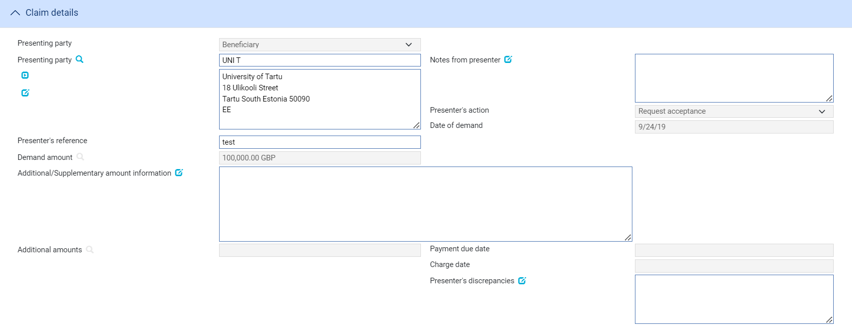

The following table explains what to enter into the fields displayed when you select Advice of Payment:

|  |  |
| --- | --- |
| Field | What to Enter |
| Sender to Receiver Information | Any narrative from the sender. |
| Payment Advice Date | The date of the original payment advice. |
| Amount Originally Claimed | The amount claimed on the original payment advice. |
| Response Received Date | The date on which you received the response. |
| Response Narrative | Any narrative from the sender. |
| Net Amount Paid | The total amount being paid by the sender of the message. |

#### Reverse Payment

The Reverse Payment payment action allows a payment to be refunded where, for example, a claim is initially paid but is subsequently found to be discrepant. The payment action is available only when a transaction is flagged as having multiple payments, with a single part payment that has already been paid.

When this payment action is selected, the part payment that has already been paid is set to ‘Paid/Reversed’.

Your bank will need to define postings to reverse the part payment. This might involve the reinstatement of any liability, if appropriate.

# Renewing a Standby Letter of Credit

This chapter explains how standby letters of credit are renewed, and renewals advised, in the system using the Renewal and Advise Renewal events.

## Renewals in Trade Innovation

When you first enter details of a standby letter of credit on your system, the system permits you to define a schedule to determine when, how often and for how much (the original amount of the standby letter of credit or its current amount) the standby letter of credit is to be renewed for. If the customer requires a renewal advice, you can also specify how soon before the renewal happens the advice is to be produced.

For information on the diary facility see the Common Facilities User Guide – Trade Innovation.

The system uses this schedule to create diary entries for the standby letter of credit which automatically generate the renewal advice and renew the standby letter of credit on the appropriate dates.

The system uses two events to handle renewal advices and renewals:

* To generate the renewal advice, the system uses the Advise Renewal event (see page 43)
* To generate the renewal itself, the system uses the Renewal event (see page 44)

Each of these two events can be configured to be generated and released automatically, requiring no manual intervention. Alternatively, they may be configured so that they require review and/or authorisation before they can be released, in which case the system generates an event at the Review or Authorise step and lists it in the Work in Progress pane in the Master Summary window.

Upon release of the Renewal event, the system updates the expiry date of the standby letter of credit and creates a new diary event for expiry, for production of the next renewal advice and for the next renewal itself, as appropriate.

If your bank has implemented credit limit checking, then, if a Renew event is configured to be generated automatically during overnight processing and an overline condition is reported, the Renew event will be generated at the Approval step in the Work in Progress pane.

### Participated Deals

If the standby letter of credit is participated and is being renewed for the original amount, renewal may result in a Drawdown/Revolve Commit Amt event being created as a subsidiary event.

1. If the participated standby letter of credit is renewed for the current amount, a Drawdown/Revolve Commit Amt event can also be generated to support customer advice generation. The commitment amount is not changed under these circumstances. This is controlled by the StandbyParticipRenewCurrAmtDrawdown system option.)

### Licenses

If there is a license attached to the standby letter of credit, then there may be additional validation during the renewal event:

* If the original amount is renewed, there must be sufficient available amount on the license
* If amount available on the license is insufficient for the renewal, you can attach new licenses to the transaction and make further reservations
* If the license expires at renewal, you may attach a new license

See the Licenses User Guide – Trade Innovation for details of licenses.

## Reviewing and Authorising a Renewal Advice

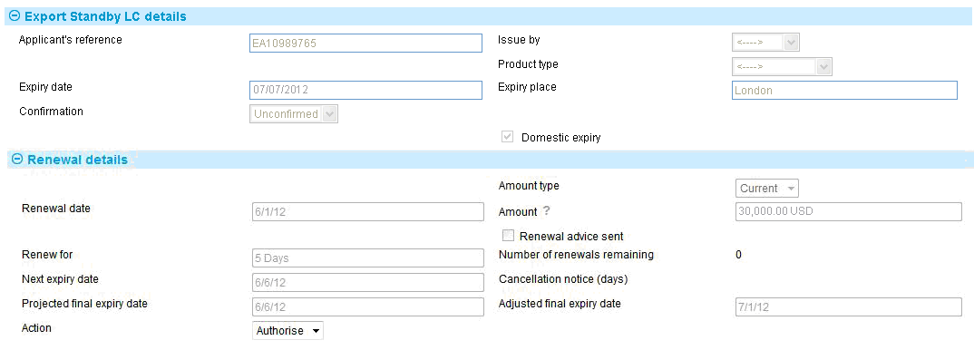

The following table lists the fields in the window used to review and authorise Advise Renewal events, explaining what they show and what to enter into those fields that permit input:

|  |  |  |
| --- | --- | --- |
| Field | What it Shows | |
| Applicant's Reference | The applicant's reference for the standby letter of credit. | |
| Issue By | The method by which the renewal advice will be sent. | |
| Product Type | The type of standby letter of credit. | |
| Expiry Date | The expiry date of the standby letter of credit. | |
| Expiry Place | The place at which the standby letter of credit expires. | |
| Confirmation | The confirmation status of the standby letter of credit, which will be one of the following: | |
|  | Confirmed | If you want the advising bank to confirm the standby letter of credit. |
|  | Unconfirmed | If you do not want the advising bank to confirm the standby letter of credit. This is the default value. |
|  | May Add | If you have no preference whether they confirm the standby letter of credit or not. |
| Domestic Expiry | This box is checked if the expiry is domestic, and blank if the expiry is overseas. | |
| Amount Type | Indicates whether the standby letter of credit is being renewed at the original amount or at its current amount. | |
| Renewal Date | The date on which the standby letter of credit is to be renewed. | |
| Amount | The amount of the standby letter of credit after renewal. | |
| Renew For | The renewal period. | |
| Next Expiry Date | The new expiry date of the standby letter of credit. | |
| Projected Final Expiry Date | The system displays the projected final expiry date based on the final renewal details. This date cannot be overwritten. | |
| Adjusted Final Expiry Date | The expiry date defined by a user or a Misys Trade Portal user.  If the projected final expiry date has been altered, it will be displayed here. | |

## Reviewing and Authorising a Renewal



The following table lists the fields in the window used to review and authorise Renewal events, explaining what they show and what to enter into those fields that permit input:

|  |  |  |
| --- | --- | --- |
| Field | What it Shows | |
| Applicant's Reference | The applicant's reference for the standby letter of credit. | |
| Issue By | The method used to send the advice. | |
| Product Type | The type of standby letter of credit. | |
| Expiry Date | The expiry date of the standby letter of credit. | |
| Expiry Place | The place at which the standby letter of credit expires. | |
| Confirmation | The confirmation status of the standby letter of credit, which will be one of the following: | |
|  | Confirmed | If you want the advising bank to confirm the standby letter of credit. |
|  | Unconfirmed | If you do not want the advising bank to confirm the standby letter of credit. This is the default value. |
|  | May Add | If you have no preference whether they confirm the standby letter of credit or not. |
| Domestic Expiry | This box is checked if the expiry is domestic, and blank if the expiry is overseas. | |
| Amount Type | Indicates whether the standby letter of credit is being renewed at the original amount or at its current amount. | |
| Renewal Date | The date on which the standby letter of credit is to be renewed. | |
| Amount | The amount of the standby letter of credit after renewal. | |
| Renewal Advice Sent | This field is checked if a renewal advice has been sent for this renewal. | |
| Renew For | The renewal period. | |
| Next Expiry Date | The new expiry date of the standby letter of credit. | |
| Projected Final Expiry Date | The system displays the projected final expiry date based on the final renewal details. This date cannot be overwritten. | |
| Adjusted Final Expiry Date | If the projected final expiry date has been altered, it will be displayed here. | |

# Reducing and Increasing Standby Letters of Credit

This chapter explains how standby letters of credit are reduced and increased, and any such changes advised in the system using the Reduction/Increase and Advise Reduction/Increase events.

## Reductions and Increases in Trade Innovation

When you first enter details of a standby letter of credit on your system, the system permits you to define a schedule to determine when, how often and by how much (as a fixed amount or a percentage of the original value of the standby letter of credit) the standby letter of credit is to be reduced or increased. If the customer requires an advice of the reduction or increase, you can also specify how soon before the reduction or increase happens the advice is to be produced. The system uses this schedule to create diary entries for the standby letter of credit which automatically generate the advice and reduce or increase the standby letter of credit on the appropriate dates.

For information on the diary facility see the Common Facilities User Guide – Trade Innovation.

The system uses two events to handle advices and reductions or increases:

* To generate the advice, it uses the Advise Reduction/Increase event (see page 45)
* To generate the reduction or increase itself, it uses the Reduction/Increase event (see page 46)

Each of these two events can be configured to be generated and released automatically, requiring no manual intervention. Alternatively, they may be configured so that they require review and/or authorisation before they can be released, in which case the system generates an event at the Review or Authorise step and lists it in the Work in Progress pane in the Master Summary window.

If your bank has implemented credit limit checking, then, if a Reduction/Increase event is configured to be generated automatically during overnight processing and an overline condition is reported, the event will be generated at the Approval step in the Work in Progress pane.

### Licenses

If there are reductions on a standby letter of credit that has a license attached, you may reinstate the unutilised reserved license amount.

If there are increases on a standby letter of credit that has a license attached, the additional amount plus the original amount will be validated against the license amount available. You have the option of adding new licenses and making further reservations, as necessary. The system will also re-check the license validity date.

See the Licenses User Guide – Trade Innovation for details of licenses.

## Reviewing and Authorising a Reduction/Increase Advice

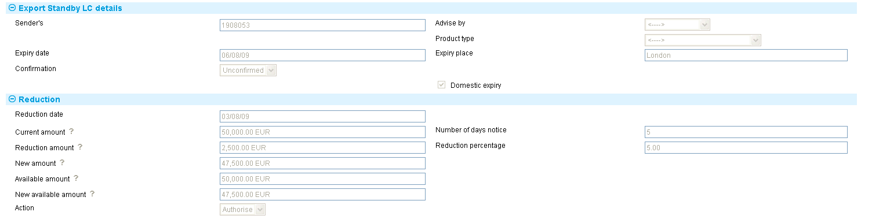

The following table lists the fields in the window used to review and authorise Advise Reduction/Increase events, explaining what they show and what to enter into those fields that permit input:

|  |  |  |
| --- | --- | --- |
| Field | What it Shows | |
| Principal's Reference | The applicant's reference for the standby letter of credit. | |
| Issue By | The method used to send the advice. | |
| Product Type | The type of standby letter of credit. | |
| Expiry Date | The expiry date of the standby letter of credit. | |
| Expiry Place | The place at which the standby letter of credit expires. | |
| Confirmation | The confirmation status of the standby letter of credit, which will be one of the following: | |
|  | Confirmed | If you want the advising bank to confirm the standby letter of credit. |
|  | Unconfirmed | If you do not want the advising bank to confirm the standby letter of credit. This is the default value. |
|  | May Add | If you have no preference whether they confirm the standby letter of credit or not. |
| Domestic Expiry | This box is checked if the expiry is domestic, and blank if the expiry is overseas. | |
| Reduction/Increase Date | The date on which the standby letter of credit is to be reduced or increased. | |
| Current Amount | The current amount of the standby letter of credit. | |
| Increase/Reduction Amount | The amount of the reduction or increase. | |
| New Amount | The amount of the standby letter of credit after the reduction or increase has been applied. | |
| Available Amount | The available amount and currency of the standby letter of credit, before the reduction or increase takes place. | |
| New Available Amount | The available amount of the standby letter of credit after the reduction or increase has taken place. | |
| Number of Days Notice | Indicates how many days before the reduction or increase takes place the advice is to be produced. | |
| Reduction/Increase Percentage | The amount of the reduction or increase, expressed as a percentage of the original standby letter of credit amount. | |
| Action | Click on one of the choices in this pane to either authorise the event or to reject it.  If you reject an Advise Reduction/Increase event, the reduction or increase itself still occurs when it is due. | |

## Reviewing and Authorising a Reduction/Increase

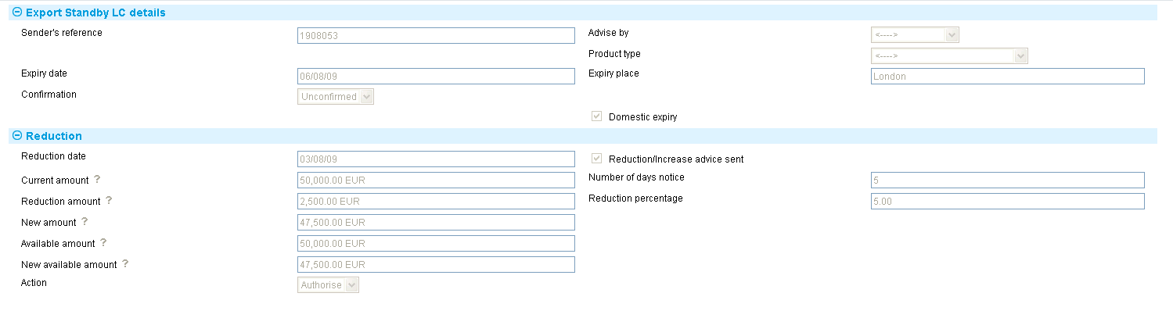

The following table lists the fields in the window used to review and authorise Reduction/Increase events, explaining what they show and what to enter into those fields that permit input:

|  |  |  |
| --- | --- | --- |
| Field | What it Shows | |
| Principal's Reference | The applicant's reference for the standby letter of credit. | |
| Issue By | The method used to send the advice. | |
| Product Type | The type of standby letter of credit. | |
| Expiry Date | The expiry date of the standby letter of credit. | |
| Expiry Place | The place at which the standby letter of credit expires. | |
| Confirmation | The confirmation status of the standby letter of credit, which will be one of the following: | |
|  | Confirmed | If you want the advising bank to confirm the standby letter of credit. |
|  | Unconfirmed | If you do not want the advising bank to confirm the standby letter of credit. This is the default value. |
|  | May Add | If you have no preference whether they confirm the standby letter of credit or not. |
| Domestic Expiry | This box is checked if the expiry is domestic, and blank if the expiry is overseas. | |
| Reduction/Increase Date | The date on which the standby letter of credit is to be reduced or increased. | |
| Reduction/Increase Advice Sent | This field is checked if an advice of the reduction/increase has been sent. | |
| Current Amount | The current amount of the standby letter of credit. | |
| Increase/ Reduction Amount | The amount of the reduction, and its currency. | |
| New Amount | The amount of the standby letter of credit after the reduction or increase has been applied. | |
| Available Amount | The available amount and currency of the standby letter of credit, before the reduction or increase takes place. | |
| New Available Amount | The available amount of the standby letter of credit after the reduction or increase has taken place. | |
| Number of Days Notice | Indicates how many days before the reduction or increase takes place an advice is to be produced. | |
| Reduction/Increase Percentage | The amount of the reduction or increase, expressed as a percentage of the original standby letter of credit amount. | |
| Action | Click on one of the choices in this pane to either authorise the event or to reject it. | |

# Making Changes to an Export Standby Letter of Credit

This chapter explains how to use the system to make amendments to an export standby letter of credit and, where necessary, to record beneficiary approval for the amendment.

It also describes using the Adjust event to make other changes to the master record.

## Amendments in Trade Innovation

A standby letter of credit can be amended using an Amend event (see page 52) at any time between the release of the Advise event and book-off.

Typically, an amendment will be initiated by the issuing bank at the request of the applicant. The issuing bank then passes details of the amendment on to the next bank in the processing chain, which will record the details and then inform the next advising bank or the beneficiary, as appropriate.

If beneficiary approval is not required for the amendment, then accounting entries and changes to the master record as a result of the amendment are carried out as soon as the Amend event has been released.

If the beneficiary's approval is required for the amendment, then the amendment does not take effect until the beneficiary's approval has been obtained and recorded in the system using a Beneficiary Response to Amend event. If this is the case, then no accounting entries are produced for the Amend event, although any charges due can be paid, if required. Once beneficiary approval has been recorded using a Beneficiary Response to Amend event, then the appropriate accounting entries are made once the Beneficiary Response to Amend event has been released. If beneficiary approval is required, then the changes made during the amendment are not applied to the master record until beneficiary approval has been obtained.

If the amendment increases the amount of a standby letter of credit that is already participated, a Drawdown/Revolve Commit Amt event may be created as a subsidiary event to decrease the commitment amount available on the participation deal. If the amendment decreases the amount of a standby letter of credit that is already participated, a Drawdown/Revolve Commit Amt event may be created as a subsidiary event to increase the commitment amount available on the participation deal, if the deal is revolving.

You can also use an Amend event to reinstate an expired or cancelled standby letter of credit's master record.

1. If you amend the expiry date of a standby letter of credit that has rolling renewal based on the expiry date, you will need to amend the rolling renewal schedule manually.

### Reversal Postings

You can use the reversal posting facilities to set up the necessary postings to handle amendments which may have an effect on any previous liability accounting, such as changes to confirmation instructions or the tenor of a payment.

### Licenses

If the master record is attached to a license, the License pane is available for you to view and amend any details of additional reservations or reinstatements when the amount or currency change.

There will also be some additional validation when you make an amendment to a master attached to a license. For example:

* If you make an amendment after the Valid To date on the license has passed, the system will either reject the amendment or allow a new license to be added, depending on how your system has been set up.
* If you change the shipment date, the new shipment date must be between the Valid From and Valid To dates on the license.
* If you change the amount or currency, the new value will be validated against those on the license. The license amount may be reserved or reinstated for the amended amount.

Note that if you are increasing the amount of a master record, then a reservation is automatically made against the license. If you are decreasing the amount, then a reinstatement is automatically made. If you change the currency, you may reinstate in the old currency and make a reservation in the new currency (assuming that the license in question allows multiple currencies).

If the master record is amended so that its status changes from Cancelled or Expired, the reinstated letter of credit value will be validated against the available amount on the license.

If the amendment requires beneficiary approval then any reservations or drawdowns required occur in the Ben Response to Amend event instead, provided that the amendment is approved.

See the Licenses User Guide – Trade Innovation for details of licenses.

### Maintaining Liability

You can change the way that liability on a transaction is shared by using the Maintain Liability event. Maintain Liability events can be used to:

* Participate a transaction
* Share customer liability on a transaction

When you press the OK button or the Pend button on the Input window of an Amend event for a participation deal, a Maintain Liability subsidiary event is automatically generated for each transaction affected by the amendment. You can use the Subsidiary Events link from the Master Summary window to view this event but it is processed and released via the participation deal Amend event.

See the Participated Deals User Guide – Trade Innovation for the Maintain Liability event.

### Handling More than One Amendment at a Time

The system permits you to have more than one Amend event in progress at the same time. If you attempt to open an Amend event for a master record that already has an Amend event in progress, or is awaiting the beneficiary's response to an amendment, the system will warn you of the fact, but will allow you to continue. The system will show the current details held for the master when the Amend event is created or opened at an Input step.

You can check whether any changes have been made to master record details between an Amend event requiring beneficiary approval being initiated and that approval being received. The Beneficiary Response to Amend event allows you to display a list of master record fields, and indicates in this list any fields where the information held on the master record differs from that held in the Beneficiary Response to Amend event. Should you discover a field that has been updated since the Amend event was initiated, you can choose whether or not to overwrite the value currently held in the master record with the value held in the Beneficiary Response to Amend event.

A field - the Use Previously Amended Amounts in Advise field - present during the Amend event when a previous amendment is still awaiting beneficiary approval permits you to decide whether or not the amount shown in tag 34b of the MT707 advice should take into account the amount of the earlier amendment.

If your system is configured so that Amend events need to be reviewed and/or authorised before release, then during these later steps the supervisor will be advised of the existence of another Amend event that has completed while the current event has been at the Review or Authorise step. They can then decide how each Amend event should be handled to ensure that the required changes are implemented.

## Displaying Changes

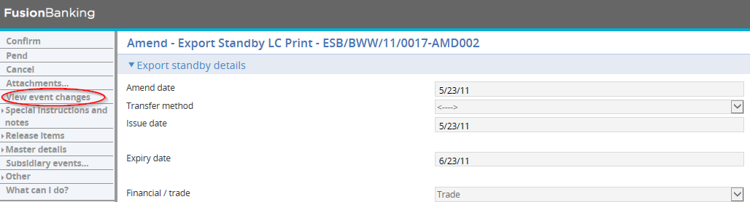

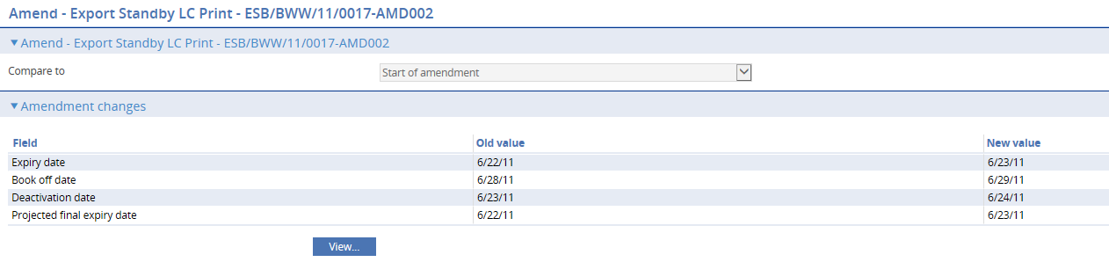

When making amendments or adjustments to a transaction the View Event Changes menu allows you - and reviewers and authorisers - to list those fields that have changed within the event. It opens a window that lists those fields whose value has changed and shows for each the value before the current event and the new value resulting from the event.

For free-format narrative fields, your bank can configure the system so that it shows either the entire content of the field in the New Value column, or just a certain number of lines (defined by the system option ViewChangesLineCount) followed by the text:

>>> plus n more lines. 'View' for details.

where n is the number of additional lines not displayed.

Selecting that entry in the list and pressing the View button displays the entire content of the field.

This window is displayed automatically when the event is opened for review or authorisation.

1. If you work with this window open, use the Refresh button to update the display to show any changes made since you opened the window.

When entering the beneficiary's response to an Amend event, the View Event Changes menu permits you to check whether any master record details have changed since the amendment event was initiated.

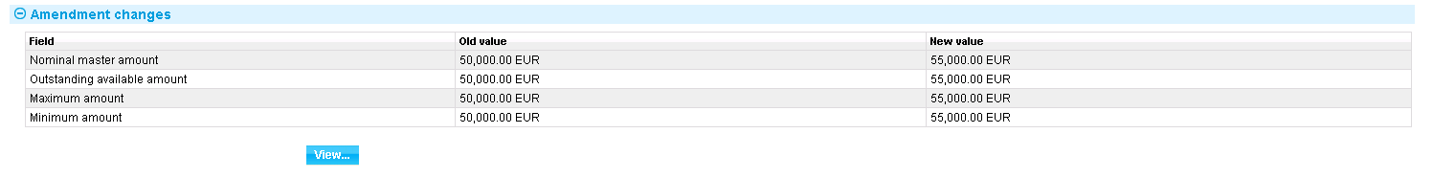

It lists those fields whose value has changed and shows for each:

* The value before the event was initiated (Old Value)
* The new value resulting from the change made in the event (New Value)
* If another event has taken place since the amendment event was initiated which has changed the value of fields held on the master record, the current value of those fields (Master Value). If this field is blank, no intervening change in value has taken place

You can see any changes made by clicking the View button. The window displayed allows you to see any intervening changes made by clicking the Intervening button.



## Amending an Export Standby Letter of Credit

To amend an export standby letter of credit, in the Master Summary window select 'Amend' from the Create New Event drop-down list and press Create. The system opens the event at either a Log step or Input step. Depending on how your system is configured, panes and fields available in log steps can be tailored for each data capture step. See the *SDK - Screen Tailoring User Guide* for details.

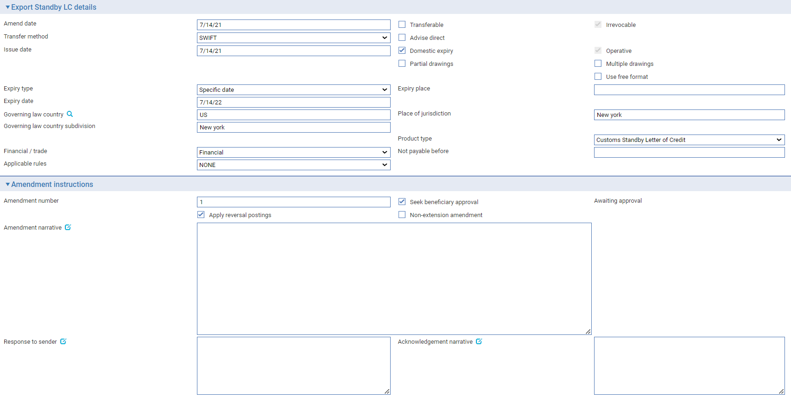

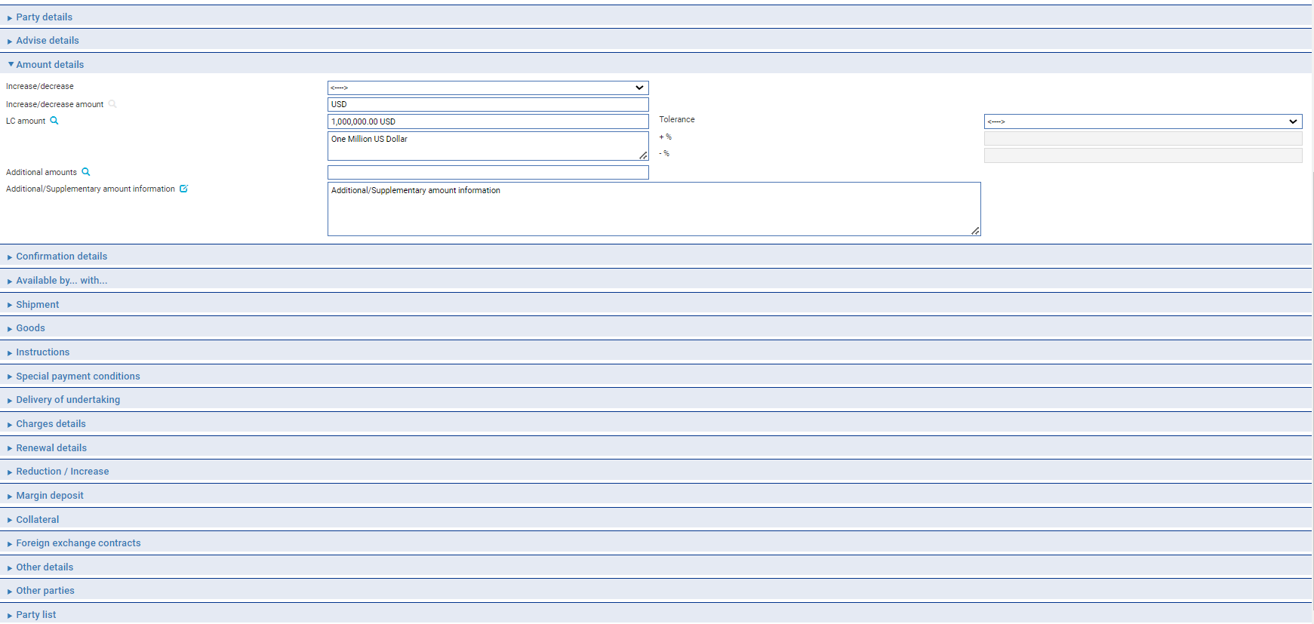

The final expiry date can be adjusted by entering the date on the Adjusted final expiry date field on the Outstanding rolling renewals pane.

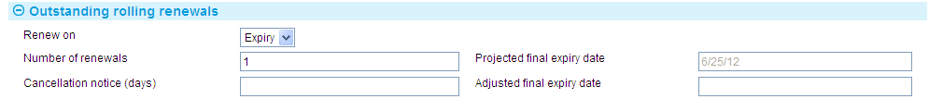

The View Event Changes menu button (see page 50) allows you to display any changes made during the event.

Depending on how your system is configured, the Amendment Narrative field may be positioned on its own in an Amendment Narrative pane. (This is controlled by the AmendAdjustEventScreenlayout system option.)

The window displays a sub-set of the information already input for the transaction, which you can overtype. Your bank can configure the event so that you cannot amend the content of the Goods Description, Documents Required and Additional Conditions fields. (This is controlled by the ProtectFieldsGoodsCondDocsOnAmend system option.)

The following additional fields are present:

|  |  |
| --- | --- |
| Field | What to Enter |
| Amend Date | The date the amendment was created on your system. |
| Apply Reversal Postings | Check this field if your bank has set up reversal postings for this event and wishes to apply them when the event is released. |
| Seek Beneficiary Approval | Check this box if beneficiary approval is required for the amendment.   1. **Seek Beneficiary Approval** flag is checked by default. Uncheck the field if beneficiary approval is not required.   Set Branch general system option ‘DoNotSeekBeneficiaryApproval’ to ‘Yes’ to change the default value of this field to unchecked. The system option only changes the default state of the field but the field can still be updated within the transaction. |
| Amendment Narrative | Any additional information about the amendment. |
| Response to Sender | Any information to be send to the person from whom you received the amendment. |
| Use Previously Amended Amounts in Advise | This field is displayed when a previous amendment is still awaiting beneficiary approval; the value of the previous amendment is displayed beneath it. If you check this field, then the amount of the previous amendment is taken into account when advising the beneficiary of the amended amount. |

1. If you amend the expiry date of a standby letter of credit that has rolling renewal based on the expiry date, you will need to adjust the rolling renewal schedule manually.

If the amount of the standby letter of credit has changed, you can enter the new amount in one of two ways:

* Use the Increase/Decrease field to select whether the change involves an increase or a decrease, then use the Increase/Decrease Amount to enter the value of the increase/decrease. When you press Refresh, the system calculates the amended amount and displays it in the Amount field
* Type the new amount into the Amount field

## Recording the Beneficiary's Response to an Amendment

If, when amending a standby letter of credit you check the Seek Beneficiary Approval flag, then the amendment does not take effect until the beneficiary's approval has been obtained and recorded in the system.

1. **Seek Beneficiary Approval** flag is checked by default. Uncheck the field if beneficiary approval is not required. Set Branch general system option ‘DoNotSeekBeneficiaryApproval’ to change the default value of this field to unchecked.

To enter details of the beneficiary's response, in the Master Summary window select 'Beneficiary Response to Amend' from the Create New Event drop-down list and press Create. The system opens the event at either a Log step or Input step. Depending on how your system is configured, panes and fields available in log steps can be tailored for each data capture step. See the *SDK - Screen Tailoring User Guide* for details.

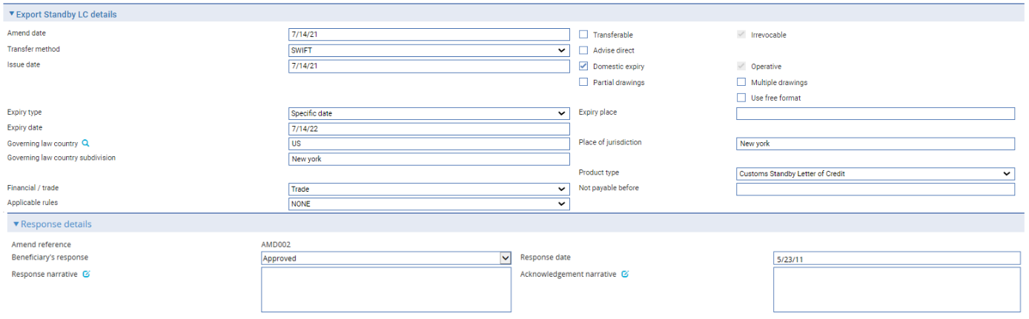

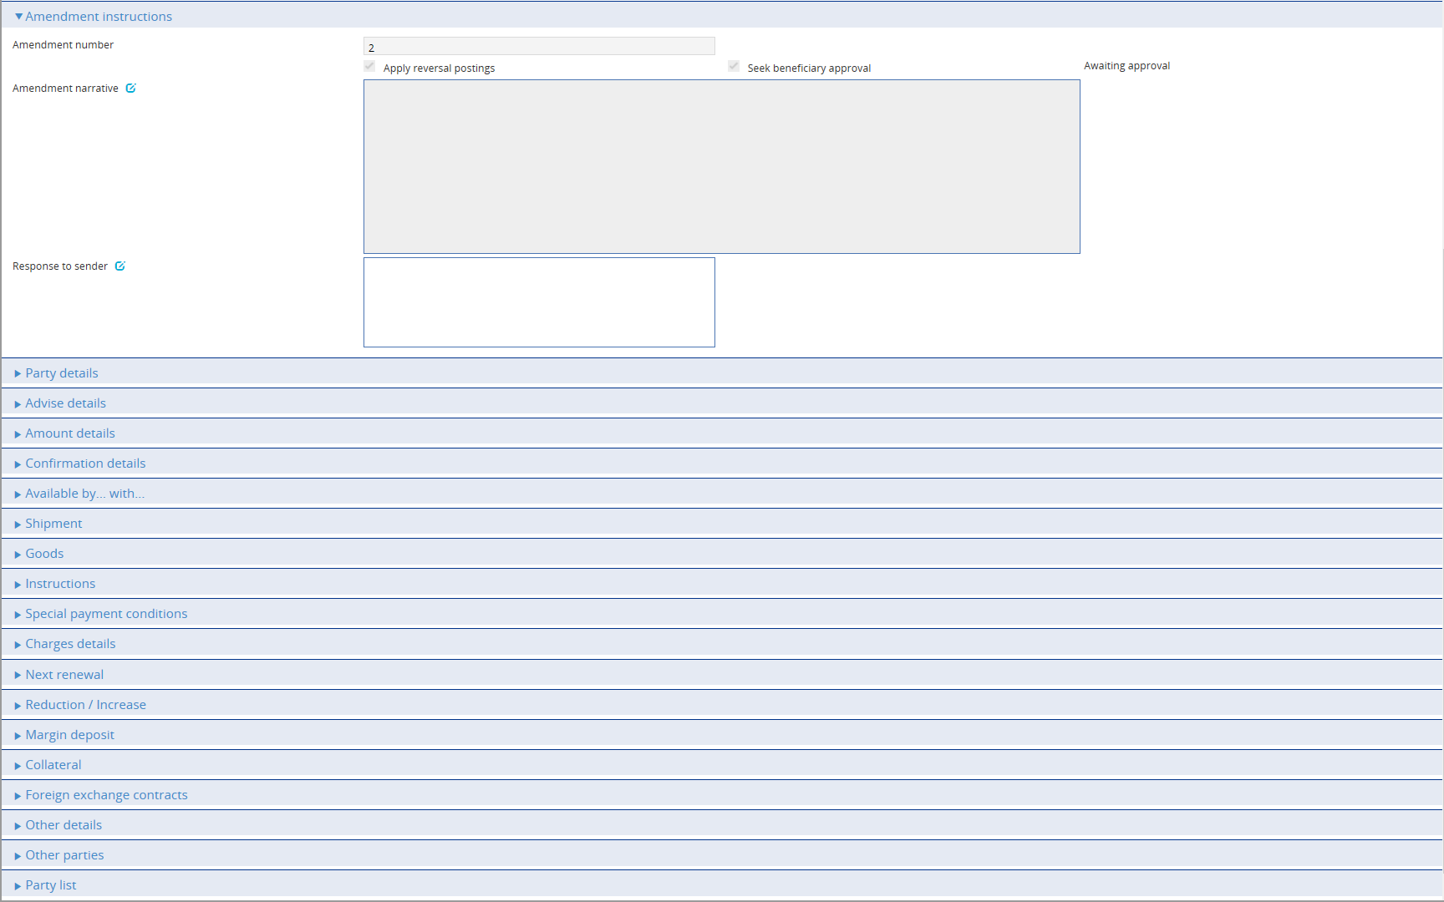

The View Event Changes menu button (see page 50) allows you to display any changes made during the event.

As with the Amend event your system may be configured so that the Amendment Narrative field is positioned on its own in an Amendment Narrative pane. (This is controlled by the AmendAdjustEventScreenLayout system option.)

Your bank can configure the event so that you cannot amend the content of the Goods Description, Documents Required and Additional Conditions fields. (This is controlled by the ProtectFieldsGoodsCondDocsOnAmend system option.)

If there is only one amendment event awaiting a beneficiary response, the system retrieves it and displays its reference. If there is more than one amendment event awaiting beneficiary response, then the Select button permits you to select the one to which the beneficiary's response relates.

In the Response Details field use the Principal's Response field to indicate whether the beneficiary has approved the amendment or rejected it. Use the Response Narrative field to enter any additional information included with response, such as the reasons for a rejection.

## Making Adjustments to the Master Record

The functionality of the Amend event allows you to make all the changes that are likely to be required in the normal course of business at the request of the applicant, and which may require beneficiary approval. The system includes an Adjust event, which contains additional functionality to allow you to make changes to all the information recorded for a transaction, with the exception of your bank's reference number for the transaction, and the status of a transaction's master record.

The Adjust event (see page 55) is designed to allow you to make changes where you need to alter details but do not need to notify other parties. This functionally is intended to allow you to correct mistakes, and should be used cautiously. If you make any changes using this functionality, you should ensure that the proper reconciliations are carried out.

### Adjusting an Export Standby Letter of Credit

To adjust a standby letter of credit, in the Master Summary window select 'Adjust' from the Create New Event drop-down list and press Create. The system opens the event at either a Log step or Input step. Depending on how your system is configured, panes and fields available in log steps can be tailored for each data capture step. See the *SDK - Screen Tailoring User Guide* for details.

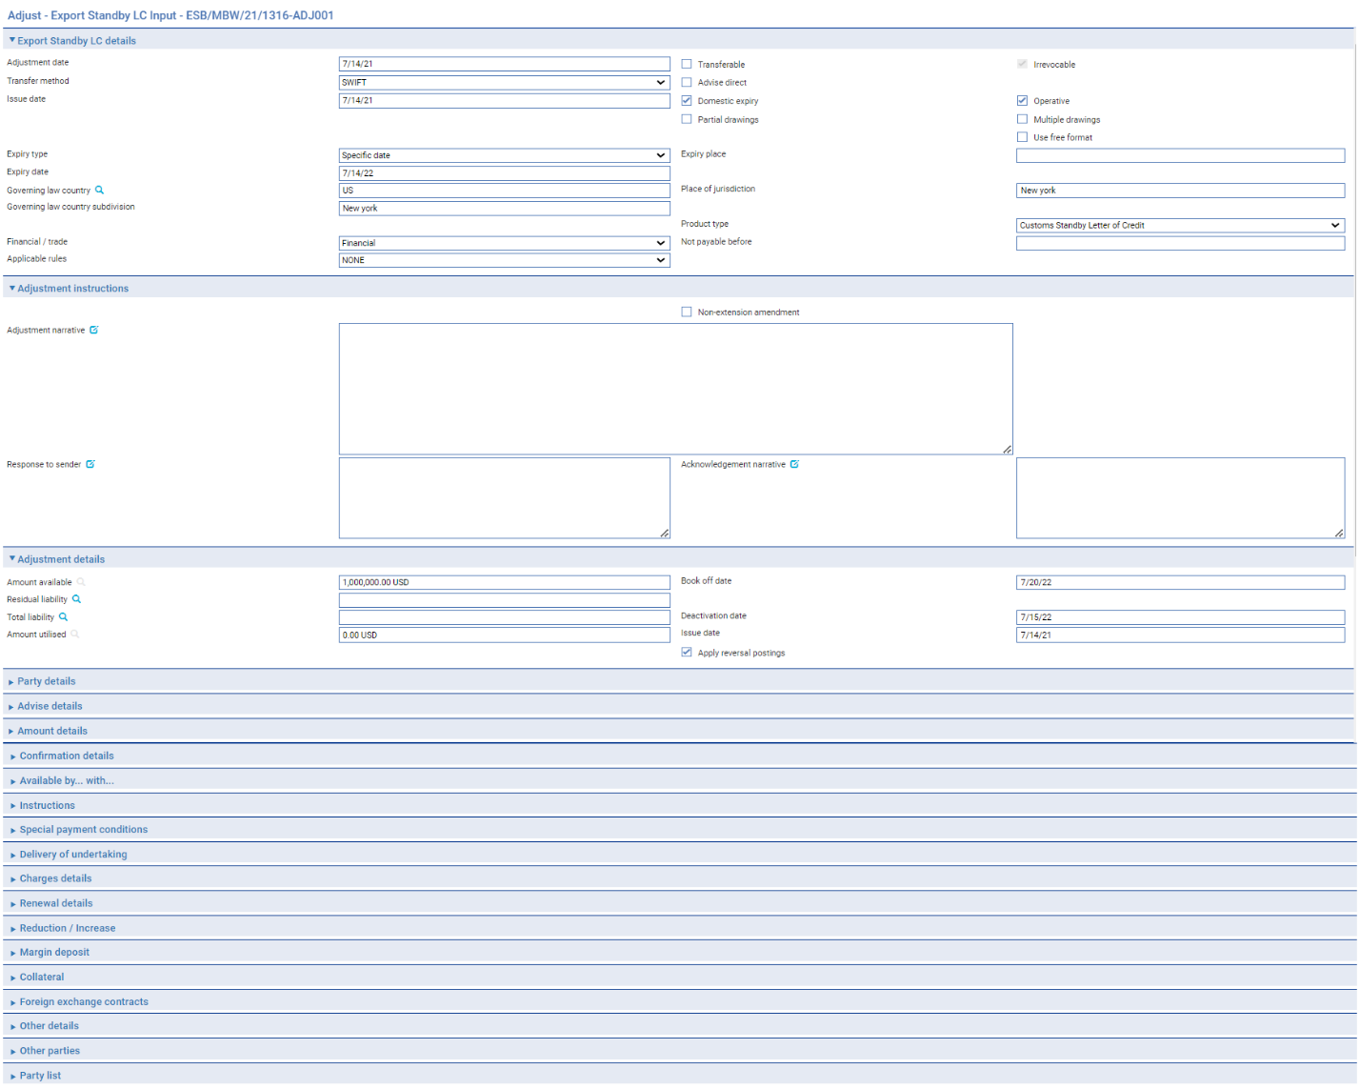

The Changes button (see page 50) allows you to display any changes made during the event.

The window displays a sub-set of the information already input for the transaction, which you can overtype.

Depending on how your system is configured, the Amendment Narrative field may be positioned on its own in an Amendment Narrative pane. (This is controlled by the AmendAdjustEventScreenlayout system option.)

During an Adjust event you can view charges and add optional charges, but cannot edit existing charges. To change charges, use a Maintain Charges event.

| Field | What it Shows |
| --- | --- |
| Adjustment Date | The date the adjustment was made. This defaults to today's date. |
| Adjustment Narrative | Identify the changes made and the reasons they were made. |
| Instructions from Applicant | Any instructions received from the applicant regarding the amendment. |
| Response to Applicant | Any information to be send to the applicant regarding the amendment. |
| Amount Available | This field displays the amount outstanding on the standby letter of credit. |
| Residual Liability | The system displays the outstanding liability amount as shown on the master record. Use this field to overwrite the figure shown on the master summary if, for any reason, the master figure is incorrect. |
| Total Liability | The system displays the outstanding liability amount as shown on the master record. Use this field to overwrite the figure shown on the master summary if, for any reason, the master figure is incorrect. |
| Amount Utilised | The amount of the standby letter of credit utilised so far. |
| Book Off Date | The system displays the standby letter of credit's book-off date, which you can amend. The system will then book off the standby letter of credit when the new book-off date is reached. |
| Deactivation Date | The system displays the date on which the standby letter of credit will become inactive (after its expiry date and any days grace period has elapsed). You can amend this date.  See the System Tailoring User Guide – Trade Innovation for the days grace period, which may be different for master records expiring locally and those expiring abroad. |
| Issue Date | The issue date of the standby letter of credit. |
| Apply Reversal Postings | Check this field if your bank has set up reversal postings for this event and wishes to apply them when the event is released. |

If the amount of the standby letter of credit has changed, you can enter the new amount in one of two ways:

* Use the Increase/Decrease field to select whether the change involves an increase or a decrease, then use the Increase/Decrease Amount to enter the value of the increase/decrease. When you press Refresh, the system calculates the amended amount and displays it in the Amount field
* Type the new amount into the Amount field

# Cancelling a Standby Letter of Credit

This chapter explains how to use the system to cancel a standby letter of credit and, where necessary, to record beneficiary approval for the cancellation.

## Cancellations

A standby letter of credit can be cancelled at any time after the release of the Advise event and book-off. However, you cannot cancel a standby letter of credit on which there is work in progress.

Typically, cancellation will be initiated by the issuing bank at the request of the applicant. The issuing bank then passes details of the cancellation on to the next bank in the processing chain, which will record them and inform the next advising bank or the beneficiary, as appropriate.

The system provides:

* A Cancel event (see page 58) which allows you to record details of the cancellation. The Cancel event includes the facility to create messages to forward details of the cancellation
* A Beneficiary Response to Cancel event (see page 58), which allows you to enter and forward details of a beneficiary's response to a cancellation notification

If beneficiary approval is not required for the cancellation, then as soon as the Cancel event has been released, accounting entries are produced to reduce the liability and liability outstanding to nil and the master record is given the status CAN, although it is not removed from the system.

If a margin deposit was made to cover the standby letter of credit then accounting entries are generated by the Cancel event to repay unutilised funds back to the customer's account.

If a standby letter of credit that has a license attached is cancelled any unutilised amount reserved can be reinstated (provided that the Automatically Reinstate parameter has been set and a reservation had previously been made).

If the beneficiary's approval is required for the cancellation, then the cancellation does not take effect until the beneficiary's approval has been obtained and recorded using the system. If this is the case, then no accounting entries are produced for the Cancel event, although any charges due can be paid, if required. Once beneficiary approval has been recorded using a Beneficiary Response to Cancel event, then the appropriate accounting entries are made once the Beneficiary Response to Cancel event has been released. If beneficiary approval is required, and is not forthcoming, then the cancellation does not take effect.

1. A cancelled standby letter of credit can be reinstated using the Amend event.

### Participated Deals

If a transaction is participated, cancelling it may result in a Drawdown/Revolve Commit Amt event being created as a subsidiary event to increase the commitment amount available on the participation deal, if the deal is revolving.

## Cancelling an Export Standby Letter of Credit

With the appropriate master record open, in the Master Summary window select 'Cancel' from the Create New Event drop-down list and press Create. The system opens the event at either a Log step or Input step. Depending on how your system is configured, panes and fields available in log steps can be tailored for each data capture step. See the *SDK - Screen Tailoring User Guide* – Trade Innovation for details.

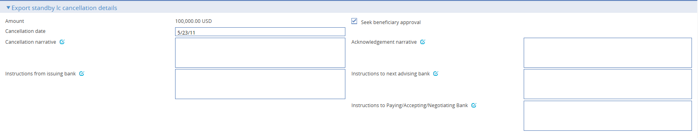

The following table lists these fields and explains what to enter into them:

|  |  |
| --- | --- |
| Field | What to Enter |
| Seek Beneficiary Approval | Check this box if beneficiary approval is required for the cancellation.   1. **Seek Beneficiary Approval** flag is checked by default. Uncheck the field if beneficiary approval is not required.   Set Branch general system option ‘DoNotSeekBeneficiaryApproval’ to ‘Yes’ to change the default value of this field to unchecked. The system option only changes the default state of the field but the field can still be updated within the transaction. |
| Cancellation Date | The date when the cancellation takes effect. This defaults to today's date, but you can change it.  Any refunds to the customer are calculated with effect from the cancellation date. |
| Cancellation Narrative | The reason for the cancellation. |
| Acknowledgement Narrative | Any additional information about the acknowledgement to sender. |
| Instructions from Issuing Bank | Any instructions from the applicant regarding the cancellation. |
| Instructions to Advising Bank | Any instructions to the advising bank regarding the cancellation. |
| Instructions to Paying/Accepting/Negotiating Bank | Any instructions to Paying/Accepting/Negotiating Bank. |

## Recording the Beneficiary's Response to a Cancellation

If, when cancelling a standby letter of credit you check the Seek Beneficiary Approval flag, then the cancellation does not take effect until the beneficiary's approval has been obtained and recorded in the system. The Beneficiary Response to Cancel event allows you to do this.

1. **Seek Beneficiary Approval** flag is checked by default. Uncheck the field if beneficiary approval is not required. Set Branch general system option ‘DoNotSeekBeneficiaryApproval’ to change the default value of this field to unchecked.

To enter details of the beneficiary's response, with the appropriate master record open, in the Master Summary window select 'Beneficiary Response to Cancel' from the Create New Event drop-down list and press Create. The system opens the event at either a Log step or Input step (see page 59), depending on how your system has been configured. The same fields are used at both steps, but an Input step shows details of the cancellation request.

### Logging the Beneficiary's Response

A Log step has only the Export LC Cancellation Details pane.

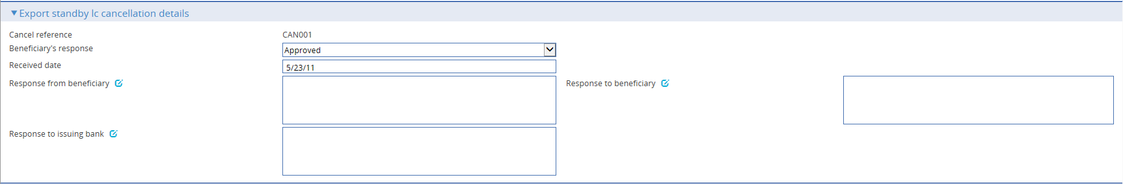

### Entering Full Details of the Beneficiary's Response

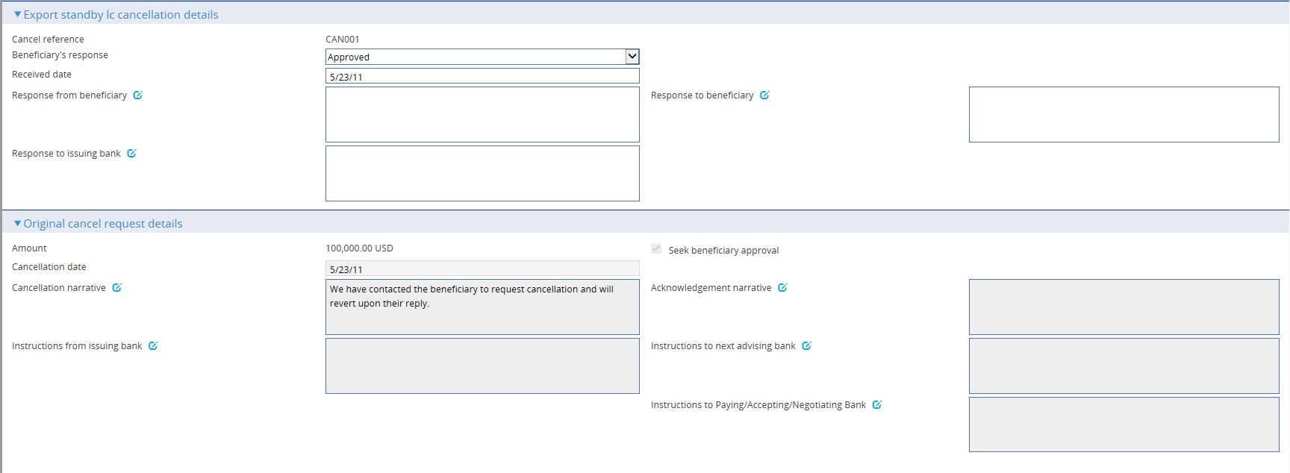

In the Beneficiary's Response pane, click on the appropriate field to indicate whether the beneficiary has approved or rejected the cancellation.

Use the Response Narrative field to enter any additional information included with the response, such as the reasons for a rejection. The remaining narrative fields in this window display information taken from the Cancel event. You can overtype this information - the Next button allows you to view the same information in display-only mode.

# Processing Additional Payment Details

This chapter explains how to use the Associated Payment Details pane to apply further processing against the payment or part payments being made.

## Processing Associated Payment Details



The Associated Items pane allows you to apply further processing against the payment or part payments being made. As payments are defined they are listed in this pane. You can select them individually and enter details of:

* An assignment to a third party (see page 60)
* A discount (see page 61) - press the Discount button
* A license - press the Licenses button. See the Licenses User Guide – Trade Innovation for further instructions

### Assigning Proceeds to a Third Party

Press the Split button that appears in the Associated Payment Details pane.

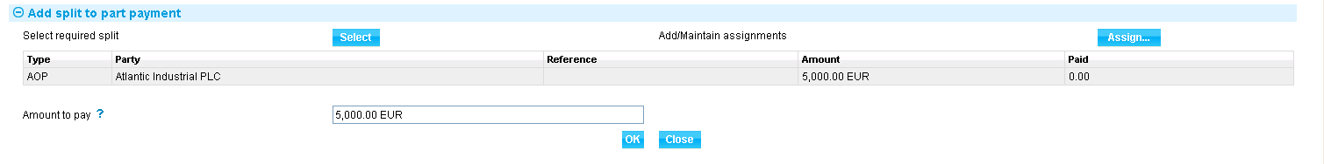

In the window that appears the system lists all assignments of proceeds (AOP), transfer letters of credit (TRF) and back-to-back letters of credit (BTB) created against the parent transaction, showing for each:

* The name of the beneficiary or assignee
* The original amount allocated
* The amount paid to date

Select the third party to whom you wish to assign proceeds and press Select.

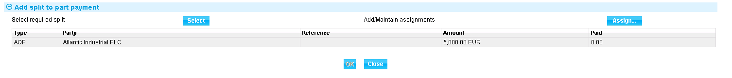

The system displays the amount to be assigned, which you can overtype. Press Assign to assign the amount to the selected third party.

## Discounting Payments

1. The functionality described in this section is available only if you do not have the financing module implemented.

For payments where you have checked both the Eligible box and the Hold box, the Discount button in the Associated Payment Details pane is enabled.

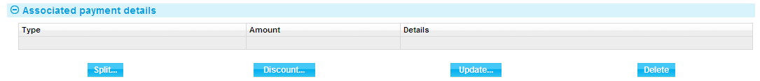

This allows you to record details of a payment to be made to the presenter before the date due under the terms of the master record.

When you press the Discount button the system opens a window for you to enter details of the discount.

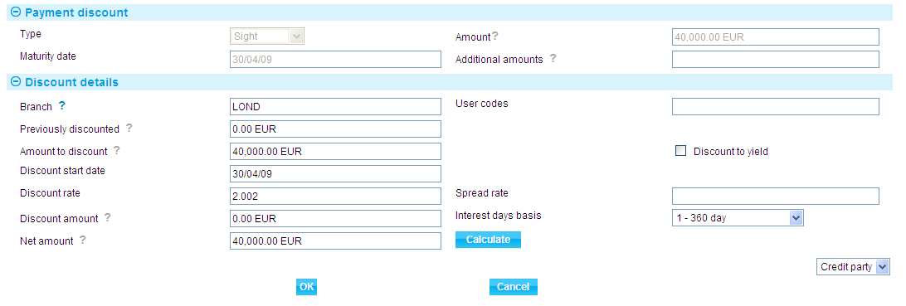

Details of the payment or part payment being discounted are displayed at the top of the window. The table below explains what to enter into the field in this window. Pressing the Calculate button updates the fields, using the values you have entered.

|  | Field | What to Enter |
| --- | --- | --- |
|  | Previously Discounted | If a discount has already been given against the transaction, the amount against which the discount was given. |
|  | Amount to Discount | The amount of the discounted payment for which the early payment is to be made. This may be up to the amount due under the part payment, including additional amounts. |
|  | Discount Date | The date the discounted payment is to be made. The system uses today's date as a default. |
|  | Spread Rate | The spread rate that has been added to the interest rate. This is used for reporting purposes only. |
|  | Days Basis | The days basis to be used to calculate the interest. A list of valid values is given in the Common Facilities User Guide – Trade Innovation. |
|  | Discount to Yield | Click once on the Discount to Yield box so that it is checked if the discount to yield formula is to be used to calculate the discount instead of the standard discount formula. |
|  | Discount Amount | The amount of the discount. If you enter the interest rate into the Discount Rate field, the system calculates the discount and displays it in this field, where you can overwrite it. Alternatively, you can enter the discount value directly into this field and the rate will be automatically recalculated. |
|  | Discount Rate | The interest rate to be used to calculate the discount interest amount. Enter the overall rate at which discount is to be calculated (including the spread).  Alternatively, you can enter the discount as an amount in the Discount Amount field. |
|  | Net Amount | The total value of the early payment, taking into account any discount due. |
|  | Discount Paid By | Indicate which party is to pay the discount on the early payment. |
|  | Branch | The branch that owns the discount deal. |

# Appendix Payment Actions and Charges

This appendix explains how the system handles the processing of charges during a payment event for export standby letters of credit.

This appendix covers only the special processing for standby letters of credit. For a full account of how the system handles charges see the Common Facilities User Guide – Trade Innovation.

## Charges

When requesting payment, or asking for authorisation to pay, for an export standby letter of credit it is sometimes necessary for the bank to advise the issuing bank of charges that will be due from the applicant. Similarly, when documents are received on an import standby letter of credit, the issuing bank may need to advise the applicant of charges due, as a request for approval is sent to the applicant. The system handles this by allowing you to claim the charges.

If you select the Release Items|Charges link during a payment event, then when you have For Master selected, the system will display an additional button - the Claim All button.

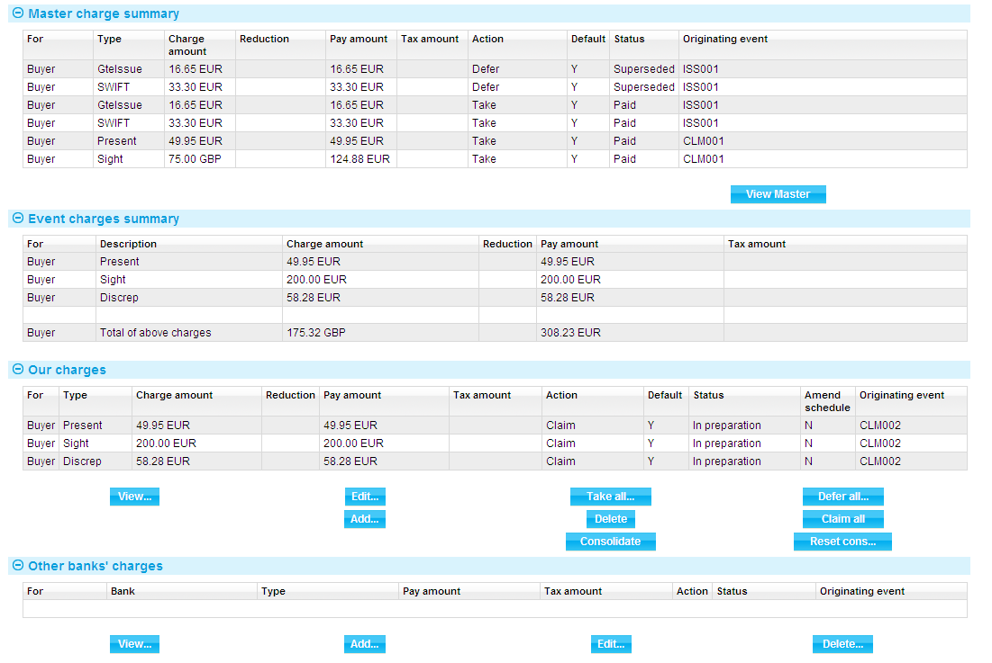

For more on the Charges Summary window see the Common Facilities User Guide – Trade Innovation.

If you press the Claim All button, the system changes the value in the Action column to 'Claim' for all charges with a status of 'Outstanding' or 'In Preparation'. When the event is completed, the status of these charges changes to 'Claimed'. This indicates that the charges have been claimed by the bank, but payment has not yet been authorised or paid. No postings are generated by the claim, since no payment has yet been made.

If the response does not authorise payment of the claim, you will need to manually take all previously-claimed charges. The system will issue a warning that these charges relate to an outstanding payment event and are being superseded. Once taken, these previously-claimed charges can be waived or edited in the usual way.

## Presenter's Actions

The following table lists all the presenter's actions supported by the system and explains when they might be used:

|  |  |
| --- | --- |
| Presenter's Action | What it Signifies |
| Request Authorisation to Pay | Discrepancies have been advised by the presenter and authorisation to pay is being requested. If this option is selected, an extra field is displayed, allowing you to enter details of discrepancies. |
| Pay and Claim Reimbursement | The sender has paid the beneficiary and has sent a claim to the reimbursing bank. |
| Request Payment | The presenter is requesting payment. |
| Request Acceptance | The presenter is requesting payment and or acceptance of drafts. |
| Sender has Debited our Account | The presenter has paid the beneficiary and has debited the receiver's account. |
| Documents Sent On Approval | Documents with discrepancies have been sent on approval. |
| Other | Used when the payment action involves more complex instructions, for example where discounting of acceptances is being requested. The Notes fields should be used to provide details. |

## Payment Actions

The Payment Action field allows you to select the appropriate action for the claim. Actions are of three types.

Payment actions indicate that the bank is paying or will pay the claim in the future. These include:

* Approve Authorisation Request
* Pay
* Pay with Financing
* Pay at Maturity
* Issue Trust Receipt Loan
* Accept
* Forward Documents
* Repay Finance

Some actions reject or refuse the claim. These include:

* Refuse Documents
* Reject
* Reject and Claim Refund
* Reject Authorisation Request

Some actions leave the claim outstanding. These include:

* Await Documents
* Request Approval from Applicant
* Issue Trust Receipt
* Issue a General Request to Applicant or Presenter

1. In addition to the standard the system actions mentioned above, your bank may define other actions (which are based upon the standard actions) in order to satisfy your internal processes. These additional actions will also be available in the drop-down list.

See the System Tailoring User Guide – Trade Innovation for instructions on defining the additional payment actions.

### The Effect of Payment Actions on Charges

The following table indicates the effect of different payment action behaviours on charges for export standby letters of credit:

| Payment  Action Behaviour | What it does | Our Charges for Buyer | Our Charges for Seller | Other Party Charges | Other Bank's Charges for Buyer | Other Bank's Charges for Seller |
| --- | --- | --- | --- | --- | --- | --- |
| Accept | The main purpose of acceptance is to confirm the maturity date of an acceptance payment and to allow the drafts to be returned or discounted. The payment is then treated as a pay at maturity, allowing the payment to be paid as the due date is reached.  This is available for acceptance payments only. | Claim | Defer | Claim | Claim | Claim |
| Approve Authorisation Request | Only available if discrepancies advised by another bank. In this case a further drop down list appears allowing the user to enter the appropriate additional authorisation details:   * See details * Accept * Remitted - note value date field is then shown * Debit sender's account * Negotiate * Claim reimbursement   This is available only if the presenter's action is 'Request Authorisation to Pay'. | Take | Take | Take | Take | Take |
| Await Documents | Used where the presentation was made in advance of the documents being received.  This is available only where presentation is by a bank. |  |  |  |  |  |
| Issue a General Request to Issuing Bank, Presenter or Transferee | This can be used to send correspondence about the claim to the issuing bank or presenter by entering details into the Notes for Presenter or Notes for Issuing Bank field, as appropriate. | Take | Take | Take | Take | Take |
| Pay | The presentation is being paid. If a single payment is being entered, then the payment will be made and an MT754 or equivalent will be sent to the principal party (issuing bank).  If the payment is mixed then this indicates the documents are payment is to be made. Each part payment is initially set to have a status of 'pay' which can be overridden as required to one of the following pay statuses:   * Pay * Pay at maturity * Accept (if acceptance part payment only) | Take | Take | Take | Take | Take |
| Pay and Claim Reimbursement | The presentation is being paid and a reimbursement claim is to be sent to the reimbursing bank. The payment is left outstanding until funds are received from the reimbursing/issuing bank. | Take | Take | Take | Take | Take |
| Pay at Maturity | The payment will be made at maturity. The payment advices such as MT754 can be produced immediately and the payment will be automatically picked up as the maturity falls due so that it can be continued and paid. | Claim | Defer | Claim | Claim | Claim |
| Pay from Suspense | As for Await Replacement Invoices, but additionally would be used to pay the second beneficiary from suspense. | Defer | Defer | Defer | Defer | Defer |
| Pay with Discrepancies | As for Pay, but discrepancy details can be entered. | Take | Take | Take | Take | Take |
| Refuse Documents | Documents are refused. No payment is made. What happens to the documents depends on what is selected in the Document Disposal field. If 'Return' is selected, payment status is set to 'Reject', otherwise it is set to 'In Progress'. If a mixed payment this applies to all part payments. If a payment if refused but documents are held this allows the claim to be continued when the presenter re-presents the required documents. That is, the item will be available for further action in the process outstanding claim. | Take | Take | Take | Take | Take |
| Reject | Used where presentation is not in order.  This is available only where presentation is by a bank. | Take | Take | Take | Take | Take |
| Reject and Claim Refund | Used where the presenting bank has debited the receiver's account. In this case details of the refund value date are included.  This is available only where presentation is by a bank. | Take | Take | Take | Take | Take |
| Reject Authorisation Request | Used to refuse a request for payment where discrepancies have been advised.  This is available only if the presenter's action is 'Request Authorisation to Pay'. | Take | Take | Take | Take | Take |
| Request Acceptance | The bank will not pay the beneficiary until funds have been received from the issuing bank. This covers both the request for payment and request for drafts to be accepted.  This is available for acceptance payments only. | Claim | Defer | Defer | Claim | Claim |
| Request Authorisation to Pay | Used when documents have discrepancies. The bank does not pay but seeks authorisation to pay from the issuing bank. | Claim | Defer | Defer | Claim | Claim |
| Repay Finance | Allows the user to create a Repay Finance event. | Take | Take | Take | Take | Take |
| Request Payment | The bank will not pay the beneficiary until funds have been received from the issuing bank. | Claim | Defer | Defer | Claim | Claim |
| Send Documents On Approval | This is essentially the same as request authorisation to pay. The documents are essentially being handled as a collection. | Claim | Defer | Defer | Claim | Claim |
| Reverse Payment | The bank reverses a part payment that has already been paid. | Take | Take | Take | Take | Take |